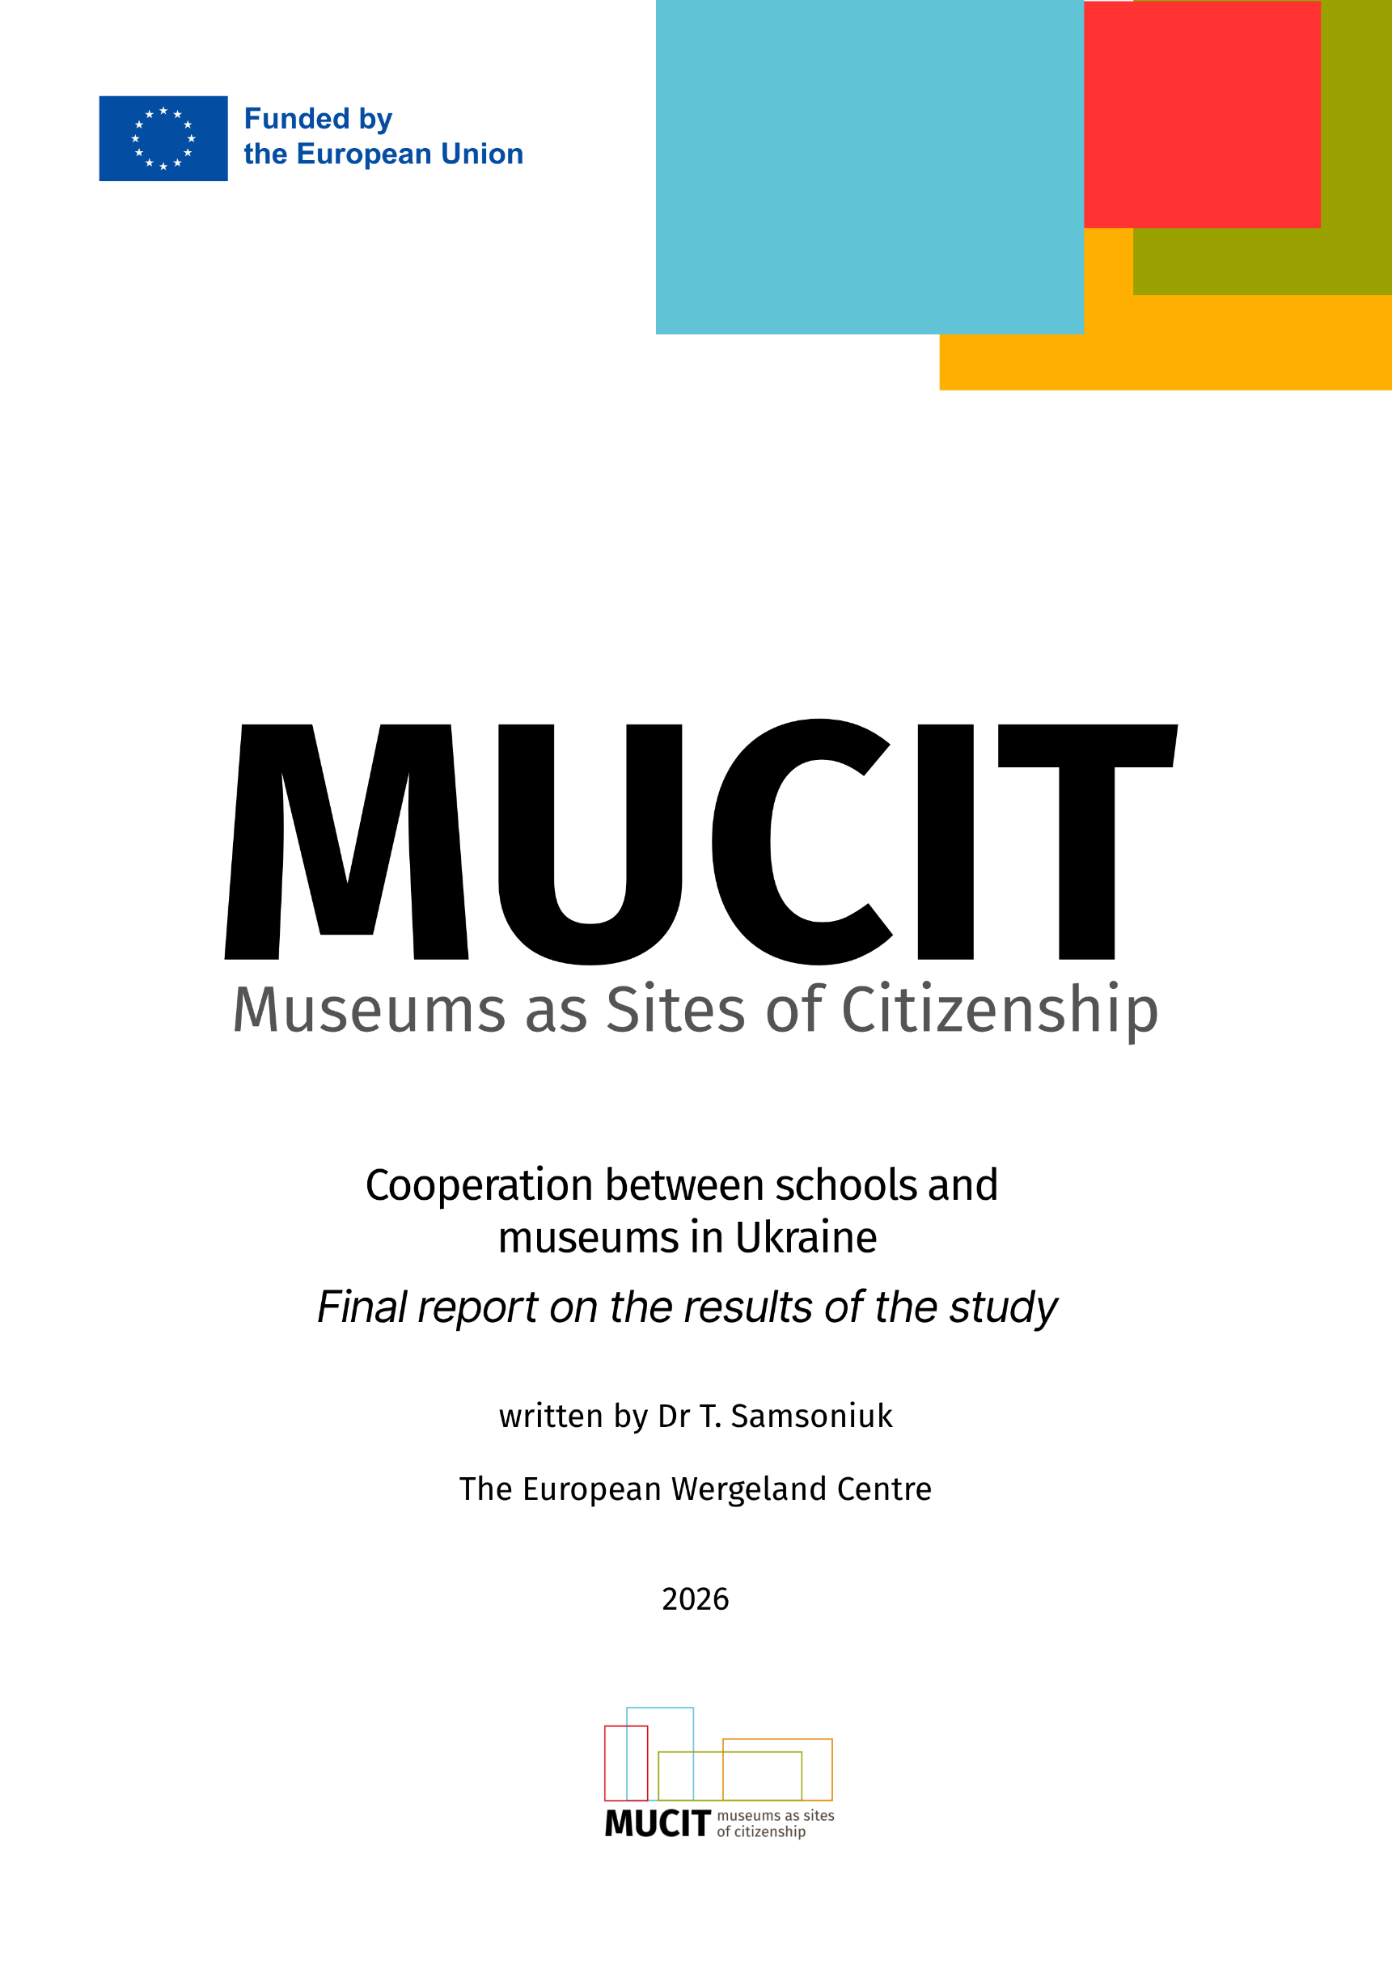

Museums as Sites of Citizenship
Cooperation between schools and museums in Ukraine
Final report on the results of the study

written by Dr T. Samsoniuk

The European Wergeland Centre
2026

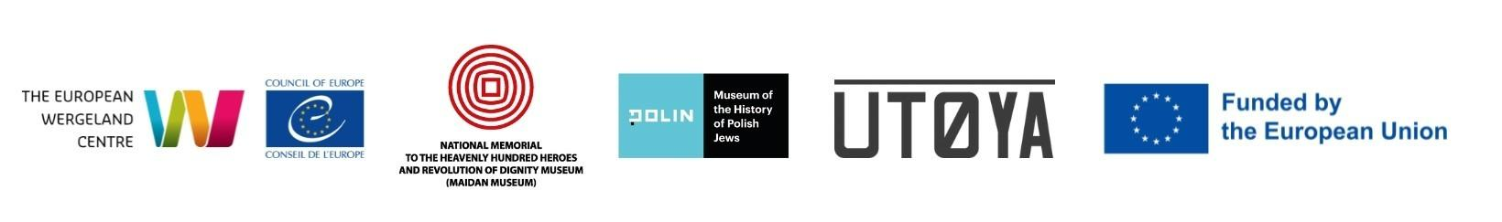

Acknowledgements
The study is carried out within the MUCIT: Museums as Sites of Citizenship project (2024-2026) implemented by the European Wergeland Centre (Norway) in partnership with Polin – Museum of History of Polish Jews (Poland) and Maidan Museum of the Revolution of Dignity (Ukraine). The project is supported by the European Commission’s Creative Europe programme. MUCIT explores the role of museums as spaces for civic learning, dialogue, participation, and the development of democratic culture. The project focuses on strengthening museums’ capacity to engage diverse audiences in meaningful conversations about history, identity, memory, human rights, and contemporary social issues. It approaches museums not only as institutions responsible for preserving and interpreting cultural heritage, but also as public spaces where people can encounter different perspectives, reflect on their own experiences, and develop the knowledge and skills needed for active citizenship.

Contents
Executive Summary 4
Research Methodology 5
Existing Research in the Field 5
Key Findings 8
Legislative Framework Analysis 10
Comparative Sectoral Analysis 12
Section 1. The School Context 12
War impact on the school-museum cooperation 13
Geographic factors influencing cooperation 13
Sustainability of the school - museum cooperation 14
Pedagogical effect of educational practices 16
Work with difficult, traumatic or controversial topics 18
Section 2. The Museum Context. 19
Factors influencing sustainability of the school-museum cooperation 19
Formal frameworks for cooperation 20
Accessibility of museums 21s
Museum staff working with educational programs 22
Pedagogical approaches and links to school curriculum 23
Complex topics, shared trauma and safe educational space 25
Impact of museum-school cooperation 26
Summary and Recommendations 27
Best Practice Example: VMUZEI (ne)dribnytsi na urotsi" (Dnipro) 30
Annex 1. Results of the Online Survey for Schools 32
Annex 2. Results of the Online Survey for Museums 39

Executive Summary

Russia’s full-scale invasion of Ukraine transformed the operational reality of educational and cultural institutions across the country. Schools and museums are forced to address critical security challenges, deliver psychosocial support, and invent new modes of community engagement. Amid these conditions, museums are shifting from traditional heritage preservation spaces into active environments for social dialogue, community support, and civic competence development.
Aligned with the New Ukrainian School (NUSh) reforms, inter-institutional partnerships aim to link formal education with experiential, interdisciplinary, and trauma-informed learning. However, collaboration between schools and cultural institutions remains largely unsystematic, relying on personal relationships or temporary grant funding.
This report provides an empirical analysis of cross-sectoral cooperation between schools, museums, libraries, and civil society. It evaluates existing regulatory frameworks, identifies operational barriers, highlights best practices, and proposes systemic policy recommendations to establish durable educational partnerships.

Research Methodology

This study employed a mixed-methods design integrating qualitative interviews, quantitative surveys, regulatory desk research, and digital content analysis.
Semi-structured interviews were conducted with representatives of various institutions and sectors. These included:
- 19 interviews with representatives of museums;
- 11 interviews with representatives of schools.
Quantitative surveys were completed by:
- 29 museum employees
- 33 school representatives
The study also included desk review of Ukrainian laws governing general secondary education, culture, museum affairs, and civic education. Particular attention was paid to the opportunities and limitations of inter-institutional cooperation, which are enshrined in current legislation, state strategies, and recommendation documents.
Digital audit of museum websites and social media platforms was carried out to evaluate public availability of educational offerings, pricing clarity, and digital resources.
Research protocols strictly adhered to the Belmont Report principles and Ukrainian legal standards, incorporating informed consent and participant withdrawal rights. The sample spans all unoccupied regions of Ukraine, encompassing diverse demographic, geographic, and institutional profiles.

Existing Research in the Field

Ukrainian research on museum pedagogy emphasises that museum environments can support critical thinking, cultural competence, research skills and students’ ability to work with tangible and intangible sources from the past. In particular, R. Mankovska states that "the museum environment contributes to the development of critical thinking". In this approach, the museum appears as an environment where the student can not only receive information, but also interpret exhibits, work with local history, ask questions about the past, and correlate it with modern experience.
Another important strand of Ukrainian research examines interaction between museums and educational institutions in the context of the New Ukrainian School. Inna Chervinska considers museum pedagogy as a tool for interaction between educational institutions and museums in the modern socio-cultural space and emphasises its interdisciplinary nature. She further argues that museum education is associated with shaping social and civic competencies, general cultural literacy, active student participation, respect for human rights, and the ability to make responsible choices, while emphasising that Ukrainian schools do not always fully use museums’ educational potential and that museum programmes need to be better aligned with teachers’ needs and curricula.
Since 2014, and particularly since the beginning of the full-scale war in 2022, museum pedagogy has increasingly addressed war, memory, traumatic experience, civic responsibility and patriotic education. Collections of materials dedicated to museum pedagogy under martial law show that Ukrainian museums are increasingly reflecting on their educational role in connection with the need to work with complex topics, support students and teachers, build civic resilience, and create safe spaces for talking about war and memory.
A separate area related to the topic is research on civic education. In these studies, the school is considered a key space for the formation of democratic values, civic culture, and legal awareness. At the same time, researchers emphasise that civic education requires not only school lessons, but also a broader cultural and social environment, the involvement of public organisations, local communities, the media, families, and partner institutions. Oksana Ovcharuk points out that, despite the existence of many civic education projects, "there have been no systemic changes on the part of educational institutions".
A review of contemporary Ukrainian sources shows that since 2022 there has been a substantial growth of practice and professional reflection on museum pedagogy in wartime, trauma-informed education, libraries as spaces of resilience, civic education and support for schools in crisis. However, these materials mostly remain sectoral: they separately describe museums, or schools. However, comprehensive empirical studies that analyse schools and museums together as a single educational and cultural ecosystem in wartime remain limited.
International research and professional guidance point to a shift from the one-off “school excursion” model towards sustained partnerships among schools, museums and other cultural institutions. For example, the British experience of the "Museums and Schools" programme directly addressed the testing of sustainable models of long-term interaction and the connection of museum activities with the national curriculum. A similar logic is supported by the professional recommendations of Museums Galleries Scotland, where museums are considered as partners in formal education, and the planning of educational programmes should be carried out in consultation with teachers and student.
A separate field of international research links museum and heritage education with the development of critical thinking, civic competencies, and the active participation of students. Studies on heritage education emphasise the importance of a close connection between the school and the museum, inclusive approach, and the active role of students in the educational process. Participatory learning approach encourages students not only to receive information in the museums, but also research, interpret, create their own products, and participate in the development of the content.
Modern international frameworks emphasise inclusion, accessibility, and digitalisation of museum education. UNESCO defines museums as spaces for cultural transmission, intercultural dialogue, learning and discussion that are important for education, social cohesion and sustainable development. European studies on inclusive arts education show that cultural institutions can become spaces for participation and self-expression, but require better accessibility, professional training, and cross-sectoral cooperation. Digital museum collections, according to NEMO, open up new opportunities for creating educational resources, distance learning, and working with audiences who cannot physically visit the museum.
A separate strand of research focuses on teaching controversial issues in the museum space. According to the Council of Europe (CoE), controversial issues are defined as topics that arouse strong feelings and emotions, and divide communities and society. They involve alternative values, competing interests, and conflicting explanations rather than facts settled by clear evidence alone. Schools are encouraged not to avoid these topics. Instead, addressing them safely helps young people build civic competences, including empathy, and respect for diverse viewpoints.
Furthermore, international approaches pay more and more attention to assessing the effectiveness of museum education, considering school-museum partnership not only as a cultural event, but as an educational practice with measurable results. Recently, The Group for Education in Museums (GEM) and Leicester University has updated its Generic Learning Outcomes model to help museums, libraries, and archives evaluate results and impact of their educational activities.
This study seeks to partially fill the existing gaps in the Ukrainian research field. It aims to explore cooperation between schools and museums not only as a pedagogical practice, but as a complex ecosystem of interaction between the cultural and educational sectors in Ukraine in the wartime.

Key Findings

The study identified structural factors that limit the sustainability of partnerships, including unequal access to resources, pressure on the education system, limited human capacity, weak cross-sector coordination, and dependence on grant funding and individual initiative.
At the same time, the findings demonstrate substantial potential for stronger cross-sector cooperation. Examples of successful partnerships between museums and schools were recorded in different regions of Ukraine, demonstrating the ability of cultural institutions to become spaces for non-formal education, dialogue, memory work and community support adjusting to different social and security challenges.

Key findings of the study can be summarized as follows:

- School-museum cooperation is predominately project-based and episodic: Interaction between schools and museums remains episodic and fragmented, sustained primarily by individual teacher or museum worker enthusiasm rather than formal institutional mechanisms.

- Schools are interested in collaborating with museums and cultural institutions asking for more links with the curriculum: Schools point to inconsistency of some museum programmes with the needs of school education. In addition, one-off excursions are less attractive to schools than long-term programmes adapted to school curricula, jointly developed lessons, or integrated learning modules.

- Pedagogical models applied by the museums are becoming more participatory: Museums are gradually transforming from "places of preservation" into spaces for education, dialogue, and community interaction. This is especially noticeable in museums that work with the themes of war, memory, human rights, local history, and cultural heritage.

- Museums lack individual staff members or structures responsible for educational activities: Educational programmes are often implemented by enthusiasts in parallel with their main work, which limits the sustainability and scaling of such initiatives.

- There is a lack of professional training for museum educators as a distinct field of studies: museum teams ask for more professional development in museum pedagogy.

- Museums lack special educational resources for schools: Only few institutions systematically develop educational programmes adapted for schools or school-age children, publish methodological materials, or clearly communicate the conditions of participation and pricing policy for school visits.

- Schools and museums face severe resource constraints to facilitate cooperation: Lack of funding and work overload are mentioned among other barriers to enhance cooperation.

- The urban-rural divide significantly shapes the models of cooperation: In large cities, cooperation between schools and museums is usually more institutionalised and better resourced, while in smaller communities it often depends on personal contacts and local initiative.

- NGOs often act as key intermediaries between the educational and cultural sectors: Civil society organizations consistently bridge the gap between schools and cultural sites by offering funding, training support and facilitation.

- There is a lack of a systematic state policy in the field of school-museum cooperation: The regulatory framework for cooperation between schools and museums lacks practical mechanisms, financial instruments and sustainable support models.

- Impact of the ongoing war is detrimental: Frontline proximity, air raid risks, and lack of shelters hinder physical site visits. Simultaneously, wartime conditions drive high demand for education centered on human rights, memory, local identity, and traumatic experiences.

Despite all the barriers and constraints, many museums have developed strong practices for working with children and young people, and successful examples of cooperation between museums and schools will continue to shape cross-sectoral interaction in the years to come.

Legislative Framework Analysis

Ukraine’s legislative landscape provides sufficient autonomy for school-museum collaboration but lacks precise operational mechanisms.
Five key policy documents were explored, including
- The Law of Ukraine "On Education"
- The Law of Ukraine "On Complete General Secondary Education"
- The Law of Ukraine "On Amendments to Certain Laws of Ukraine on Improving the Mechanisms for Forming a Network of Lyceums for the Introduction of High-Quality Specialised Secondary Education"
- The Law of Ukraine "On Museums and Museum Affairs"
- Law of Ukraine "On Extracurricular Education"
The basic framework document in this context is the Law of Ukraine "On Education". It defines education as the basis for the intellectual, spiritual, physical, and cultural development of the individual and establishes the competence approach as one of the key principles of educational policy. It provides a vision of a modern school which develops not only subject knowledge, but competences “for life”, including civic, social, cultural, information and communication competencies, in line with the "New Ukrainian School" reform. The emphasis is gradually shifting from the transfer of knowledge to development of competencies, including democratic, individual educational trajectories, civic action, and the ability of students to apply knowledge in real-life situations. It is this logic that opens up space for wider participation of cultural institutions in the formal, non-formal and extracurricular education.
The Law of Ukraine "On Complete General Secondary Education" further strengthens this framework. For interinstitutional cooperation, the provisions on the autonomy of the educational institution, the possibility of concluding civil law agreements to ensure the activities of the school, as well as the norms that open up space for partnerships in the field of general secondary education are important. This means that the school has the legal capacity to engage external resources, partner institutions and non-formal educational practices if they help to achieve the learning outcomes defined by state standards and the institution's educational programme.
The reform of the upper secondary education within the NUSh reform is of particular importance for the development of cooperation between schools and cultural institutions. The Law of Ukraine "On Amendments to Certain Laws of Ukraine on Improving the Mechanisms for Forming a Network of Lyceums for the Introduction of High-Quality Specialised Secondary Education" structures profile high schools (grades 10–12) to emphasize student choice, civic active citizenship, and elective specializations. This design creates a direct pathway for deep integration with museums and research institutions. .
The State Curriculum for Specialised Secondary Education directly emphasises the formation of civic competencies, Ukrainian national and civic identity, social activity, responsibility, respect for human rights and freedoms, and the ability to interact constructively. This creates a direct substantive link between the reform of secondary school and the potential of museums, libraries, and NGOs. It is these institutions that have the resources to work with historical memory, cultural heritage, human rights, local history, democratic values, media literacy, volunteering, and civic participation practices.
Within the framework of a specialised school, cultural institutions can be involved not only as places for one-off excursions, but as partners for elective courses, interdisciplinary modules, research projects, civic education practices, local historical research, educational routes, work with archival and museum sources, public presentations, and student projects. Cooperation in high school is particularly promising, where students are already capable of reflection, independent research, critical analysis of complex topics, and participation in public community initiatives.
At the same time, educational legislation itself does not detail the mechanisms of such cooperation. It creates a framework of autonomy and flexibility, but does not define a separate procedure by which a museum lesson, a library programme, or an NGO educational module can be systematically integrated into the school's educational programme. The issues of financing such programmes, payment for the services of cultural institutions, organisation of safe logistics, distribution of responsibility between the school and the partner, as well as assessment of learning outcomes obtained in an informal or mixed educational environment, remain insufficiently regulated.
Separate regulations govern activities of the museums as potential partners of the school. The key document is the Law of Ukraine "On Museums and Museum Affairs", which regulates the legal, economic and social principles of the establishment and operation of museums in Ukraine. The Law mandates cultural-educational programming as a core museum function opening for educational interaction with the school.
The Law of Ukraine "On Extracurricular Education" includes cultural institutions in the system of out-of-school education and provides legal grounds for recognizing competencies gained through extracurricular and non-formal programs. For the topic of this study, this provision is particularly important as it creates a bridge between formal school and the informal or extracurricular educational practices of museums and NGOs.
Although the Ukrainian legislation creates a sufficiently broad framework for cooperation between schools and museums as well as provides sufficient autonomy for inter-institutional interaction, operational conditions for these opportunities remain weak. Policy documents analysed do not provide for building sustainable educational partnerships, as there is systemic lack of implementation tools: models for crediting learning outcomes, financial mechanisms to support school visits, and procedures for integrating educational programmes of the museums into the educational process. Further development of the school – museum partnerships depends on the ability of the state, local communities, and the institutions themselves to transform the already existing autonomy into regular pedagogical practice.

Comparative Sectoral Analysis

Section 1. The School Context
This part of the study focuses on the comparison of school and museum contexts in which their cooperation occurs, or does not occur. To explore school-museum cooperation from the school perspective, interviews were conducted with 12 schools across Ukraine, except for occupied areas. The sample covered both large urban lyceums and colleges with 1,000 to 3,000 students (Rivne, Khmelnytskyi, Ivano-Frankivsk, Zaporizhzhia) and small schools in peripheral areas with only 200–400 students (Liubymivka in Kherson region, Shakhtarske in Dnipropetrovsk region). Geographically, the cases cover both relatively stable regions – Rivne, Khmelnytskyi, Ivano-Frankivsk, and partly Kyiv – and border, frontline, de-occupied or territories under constant shelling – Kharkiv, Sumy, Zaporizhzhia, and Kherson region. The specialisation of the institutions is also very different: the sample includes academic lyceums, art schools, STEM- and IT-focused institutions, natural science lyceums, vocational colleges, and schools with a historical or humanitarian focus. It is this heterogeneity that allows us to consider a wide range of conditions in which the interaction between schools and museums functions today in Ukraine.

War impact on the school-museum cooperation

The study shows that cooperation between schools and museums is shaped in a situation of profoundly unequal security contexts. Some operate in relatively stable urban environments with a developed cultural infrastructure, while others are based in post-occupation or frontline communities, where cultural interaction gives way to the basic needs of security, psychological stabilisation and restoration of the educational process. Thus, in Rivne, Kyiv, and Okhtyrka, school-museum cooperation has become part of a broader educational ecosystem and museums engage in research projects of the Junior Academies of Sciences, supports school lessons on memory, local history, and civic education. While in Sumy or Zaporizhzhia, the online learning format at schools, security risks, and mobility restrictions considerably limit any opportunities for vigorous cooperation. The war heavily affects the very structure of school-museum cooperation. In conditions of relative stability, the museum remains a resource for civic education, research, and cultural participation. While in the mode of limited mobility, cooperation shifts to a mixed or online format, often losing the physical and emotional experience of interacting with the exhibit, or the focus moves from educational purposes to social recovery, dealing with trauma, and restoring a basic "sense of normality".

Geographic factors influencing cooperation

Geography has emerged as a major driver of inequality in the context of the school-museum cooperation. Schools in safer large cities have better access to museums, libraries, theaters, universities, and public spaces. Schools on the periphery, in small communities or at the frontline often rely on online programs at the museums, occasional trips to the regional centre, or the occasional initiative of a particular teacher. In the Shakhtarske case, the distance from the Dnipro made systemic cooperation difficult even before the war, and after 2022 it became even less stable. In frontline areas, cultural cooperation is actually subordinate to basic issues of security, the restoration of education, and overcoming the consequences of the occupation.

Addressing different needs depending on the geography of schools, museums adapt their educational programs – from on-site work to hybrid solutions, “museums in the suitcase” and mobile exhibitions.

Sustainability of the school - museum cooperation

As it appears from the survey targeting schools, sustainability of school-museum cooperation only to some extent depends on the existence of formal agreements. Only 29.4% of the surveyed school representatives confirmed that they have formalised agreements with museums.
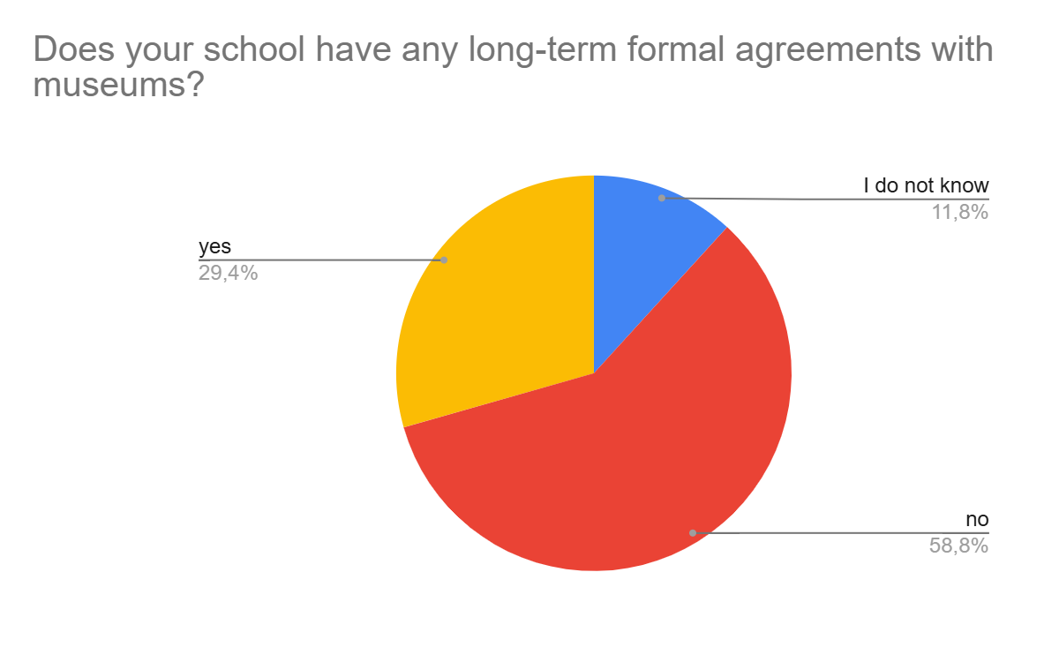
Does your school have any formalised agreements for long term cooperation with museums?

The most sustainable models emerge where formal agreements are supported by a targeted pedagogical effort. In frontline areas, schools report that formal agreements between schools and museums do not have a significant impact on interaction between the school and the cultural institution. In these vulnerable conditions, school-museum interaction relies mostly on personal initiative.
According to responses in the survey, ability of the schools and museums to maintain regular, pedagogically meaningful, and adaptive interaction in the conditions of war, staffing constraints, and unequal access to cultural infrastructure depends rather on a combination of institutional support, personal initiative, professional expertise of museum educators, the ability of museums to adapt their offers to the school curriculum and other factors.

What factors would increase sustainability of the school-museum cooperation?
(citations of respondents of the teacher survey)
Integration into school curriculum  “Integration of museum activities into the school curriculum”, “experiential learning in the museums and more active student participation” | Support from the school leadership  “Interest from the school administration”, “coordination of the cooperation by a dedicated teacher”
Interesting educational content, incl digital available online  “I wish museums offered different educational programs: lectures, meetings with interesting speakers, master classes, workshops etc”, “accessibility of exhibitions online” | Clear long-term cooperation plans  “Implementation of a joint long-term project”, “First of all, a clear plan for such cooperation”
Teacher training and support  “More information and training for teachers”, “Trainings for teachers on how to work with museum exhibits, quality methodological resources for teachers” | Financial support  “Better ticket prices”, “Increased safety and support with transport to the museum”,
Good communication and information flow  “School administration needs to be informed about educational opportunities in the museums on a systemic basis” | Stronger capacity of museums in facilitating educational activities  “Larger number of museum educators in the museum teams”

It is worth noting that some teachers mention libraries as sometimes more accessible partners for schools than museums. Libraries are often closer geographically, their operation is less formalised, they are more flexible in educational formats and able to respond more quickly to the school and community needs. A Kharkiv school describes a positive experience with the Central Library of Slobidsky district in Kharkiv, which has become not just a place for reading, but a space for socialisation, support for children, interaction with parents, thematic classes, and safe meetings during the wartime.
Other respondents emphasise the importance of including civil society organisations to complement traditional school-museum cooperation by acting as flexible, multi-functional intermediaries that bridge gaps in formal education and institutional resources.

Pedagogical effect of educational practices

Excursions dominate among different formats of the educational programs in the museums offered to schools who participated in the survey. According to teachers, 88.2% of museum visits could be classified as excursions – the traditional education model, where students are mostly passive listeners:
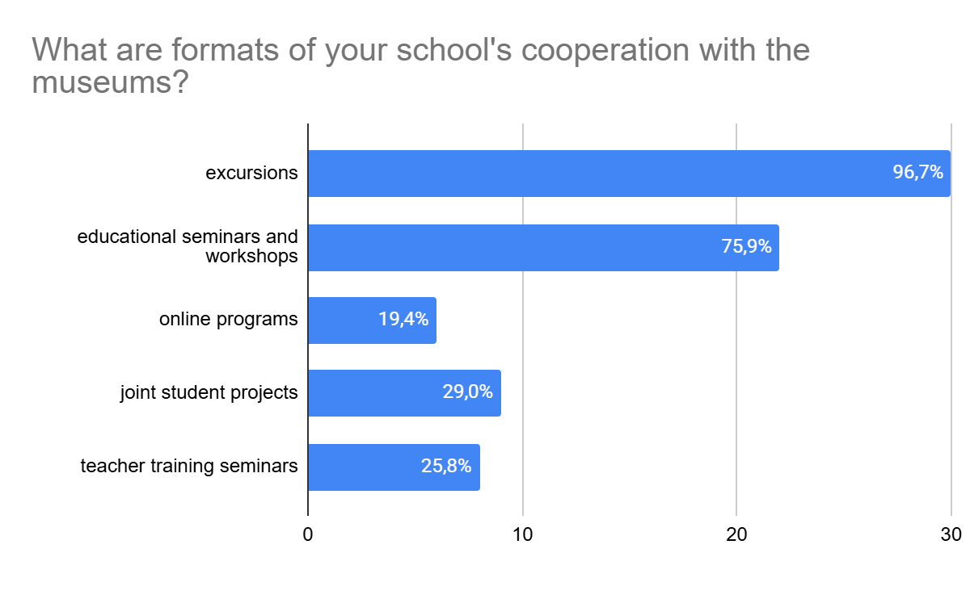
In what formats does the school cooperate with museums and other cultural institutions?

School respondents report that a museum visit is rather often linked to the curriculum. 79,4% of the respondents report that museum visits in their schools are fully or partially coordinated with topics taught in classrooms, while 17.6% answered that the visit to the museum was not linked to the curriculum at all.
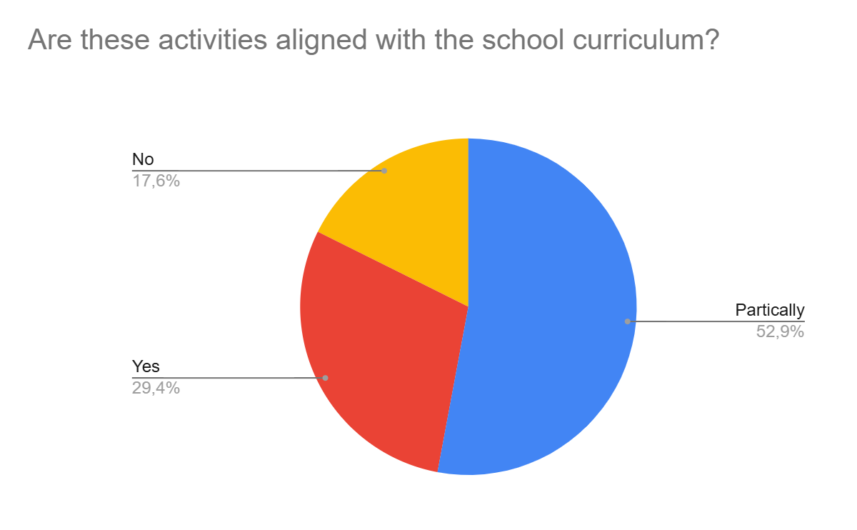
Are such activities aligned with the school curriculum?

Analysis of the interviews shows the strongest pedagogic effects where the museum ceases to be a place for a "one-time excursion" and becomes part of the educational process and civic education. Schools that participated in the survey report that they highly value cooperation with museums when it is integrated into the educational process through research projects, reflection in classrooms, student presentations, and even the role of students as tour guides or content creators.
Schools also claim that the pedagogical value of cooperation with museums heavily depends on the role of the teacher as a mediator between the museum and the student. Respondents report that the educational visit to a museum is most efficient where the teacher sets a clear goal, prepares the children for the visit, sets a specific research or reflective task, and returns to the museum experience after the tour for a reflection or a follow-up activity.
Active student participation is another factor of a successful educational programme in the museum. Many mention that the passive model of "the guide speaks – the students listen" museum visit provides the lowest pedagogical impact.
Finally, the study documented a strong accumulated fatigue from online formats of educational programs, including in the museums. In frontline areas, however, online tours and remote museum educational practices have become the only way to maintain access to museum resources in the situation of constant shelling, lack of shelters, or limited mobility. Respondents consistently emphasised that the prolonged dominance of online formats reduced children's participation, and increased attention fatigue. Students get used to the role of "screen listeners", become disengaged and lose emotional connection with the educational material. Some of the respondents explicitly emphasised that "the screen will not convey" the experience of contact with the museum object, and others mentioned considerably weaker reflection when the educational programs in the museums are carried out online. In many cases, respondents emphasise that it is critically important for children to see an exhibit in person, to move around the space, to interact with each other, and actively participate in educational activities in the museum.

Work with difficult, traumatic or controversial topics

Analysis of the interviews shows that in recent years there has been a fundamental shift in the very understanding of "difficult and controversial topics" in the Ukrainian education context. Whereas previously complexity was mainly associated with historically distant traumatic events – the Holodomor, the Holocaust, the Second World War, repressions or Chernobyl – today the focus of pedagogical attention is shifting to the experience of the ongoing war, everyday survival, loss of home, occupation, living in conditions of danger and constant uncertainty.
The key transformation is that a difficult topic has ceased to be merely a subject of historical reflection and has become part of the daily experience of children, teachers and communities. While in the case of the Holocaust or the Holodomor, there is a temporal emotional distance buffer between the child and the event that allows working with the topic through historical reflection, the current war does not have such a distance. In many interviews, the current war is described as a difficult and sometimes controversial topic, sparking the need to react emotionally, empathise or reflect on their own experience.
Decolonisation emerges as another complex and controversial topic that goes beyond changing names, programmes, or museum exhibitions. School interviews show that children are often caught between different narratives at school, in the family, in media, and in the local community. The respondents mentioned examples when classroom discussion about decolonisation ran into family Soviet or pro-Russian opinions. Debanking Russian myths about a common history, language, or “brotherly peoples” is a challenging task where schools would like to rely on museums through an interactive and dialogic approach.
In addition, the challenge lies in teachers’ skills to deal with difficult or controversial issues. In the case of historical events, educators have relatively established methodologies and educational materials. Instead, working with the topic of the current war requires completely different approaches – trauma-informed pedagogy, flexible facilitation, consideration of the individual experiences of children, and the right not to participate in certain discussions.
At the same time, perception of historically distant topics, e.g. the Holodomor, the Second World War, Soviet repressions is changing, as students increasingly interpret historical traumas through their own experiences of loss, occupation, evacuation, or living under shelling. Respondents mention that approaches to teaching about sensitive historical events need to be revised too.
Some schools report that museums are much better prepared to work with the content than to deal with children's emotional reactions, often lacking skills to reduce emotional pressure, create conditions for the gradual restoration of trust, safe contact, and a return to the ability to talk about difficult issues. Respondents repeatedly emphasise that museum staff rarely asks about the composition of the class, the presence of children with traumatic experiences, or the level of emotional readiness of the group prior to the museum visit. As a result, it is the teacher who often becomes the only mediator between a difficult or controversial topic and the psychological safety of the students. Being prepared for a particular group of students is especially important when in the same class there may be children of military personnel, IDPs, children from occupied territories, children who have lost their loved ones - and children who experience the war rather indirectly. In these contexts, educational activities in the museum space require preliminary discussion between the teacher and museum educator for a better understanding of the classroom context, a soft entry into the topic, the possibility of a pause, reflection and a safe end to the conversation not to cause harm.

Section 2. The Museum Context.

Factors influencing sustainability of the school-museum cooperation

The open-ended responses in the online survey show that museums believe the sustainability of the partnership primarily depends on the interest of schools, the support of the authorities, the existence of formal agreements, availability of funding and other factors:

What factors would increase sustainability of the school-museum cooperation?
(citations of respondents of the museum survey)
More interest from the schools  “Stronger cooperation between schools and museums depends on the school’s interest, only few teachers realize the value of students’ work with the museum”, “more interest from the local schools” | State and local government support policies  “State program to support museum pedagogy”, “support of local authorities”, “interest from the authorities, support with transport”, “higher salary for museum workers would allow for strengthening capacity of the museums”
Stronger links between museum programs and school curriculum  “Stronger awareness that for the school, the museum is not just a place to visit for an excursion, it is a partner in teaching”, “Stronger links to curriculum. Educational activities in the museums should aim to complement teaching in a number of subjects - history, arts, civic education”. | Stronger capacity of the museums  “there is need for a qualified museum personnel who would work on strengthening educational programs for schools”
Formal frameworks and systemic planning  “Not just single excursions, but a coordinated annual plan with topics, dates and formats of educational activities. Cooperation gets more sustainable when museum is well integrated in the education process at school”.  “I wish we cooperated more systemic, not through one-off events” | Modernization and financial support  “budget for cooperation with the schools”, “we need a more modern equipment at the museum to attract school audiences”

Formal frameworks for cooperation

Institutional cooperation between museums and schools in Ukraine often remains insufficiently formalised. The data from the online survey showed that only 34.5% of museums have signed memoranda/agreements on cooperation with schools. Many museums develop their own solutions to facilitate partnerships with schools without any formal frameworks. In the Bila Tserkva Museum of Local Lore, for example, there are no official agreements with schools, however due to an internal distribution of respon-sibilities, when each museum researcher is assigned to several educational institutions, cooperation with schools advances in a coherent and sustainable way.
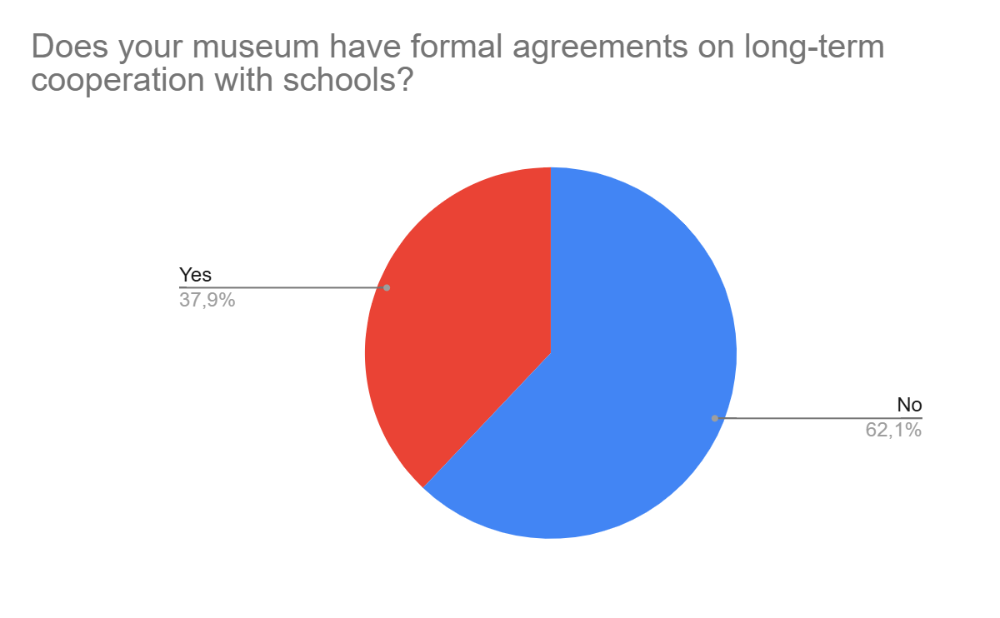
Does the museum have any formal agreements for long-term cooperation with schools?

At the same time, the interviews show a more complex picture: even where agreements or memoranda exist, they do not always translate into regular educational practice. Therefore, the main challenge is not only the lack of formalisation, but also the lack of sustainable institutional mechanisms that would bring together the school, the museum and the educational authorities. The data show that Ukrainian museum-school cooperation is in transition from occasional contacts and personal agreements to more systematic educational partnerships. Thus, for example, the National Museum of History of Ukraine has set up a separate department for cooperation with schools, although it recognises the lack of resources for the more active work in this area.

Accessibility of museums

According to the interviewees, the museum-school cooperation in Ukraine largely depends on a comprehensive access infrastructure: transport support, safe spaces, digital solutions, mobile formats, inter-institutional coordination and inclusive practices. During the war, it is the ability of a museum to adapt to security, geographical and social challenges that determines the sustainability of its cooperation with schools.
The accessibility of museums in Ukraine for cooperation with schools is determined by a set of structural conditions – logistics, funding, geography and security. Interviews show that after 2022, the concept of an "accessible museum" has changed significantly. Whereas previously accessibility was mainly associated with the cost of a ticket or territorial proximity, today security has become a critical factor. The availability of a shelter, response protocols during air raid alerts, and a physically safe route directly influence the decisions of museums regarding the acceptance of school groups. The shelter itself has become part of the museum's educational infrastructure, and security capacity has become a new criterion for the competitiveness of a cultural institution in working with schools. Thus, in the absence of a shelter, and in the winter period, of heating and electricity, the National Museum of Military History (Kyiv) actually stopped accepting organised groups of schoolchildren. The situation is similar in the Khortytsia National Reserve (Zaporizhzhia), where a significant part of the educational projects has been transformed or put on hold for security reasons.
The war has become a catalyst for the search for new accessible models for school-museum cooperation. Along with the classic "school goes to the museum" model, mobile, hybrid and digital formats are becoming increasingly important, when “the museum goes to school”. 72.4% of the museums who participated in the survey do not have any solutions for remote educational programmes, and 13.8% indicated that they are working on the introduction of the remote formats.
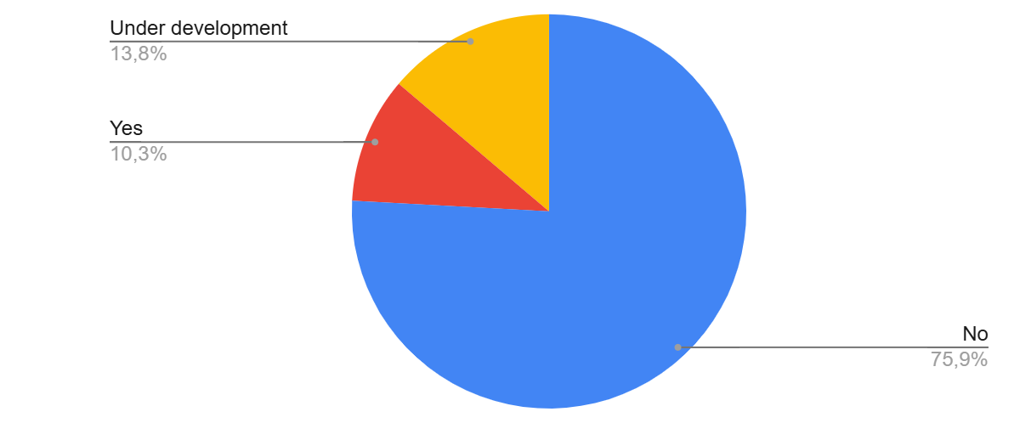
Does your museum have online or remote programs for schools?

Remote solutions help to overcome financial and safety barriers and are especially important for small communities and remote regions. Online lessons, broadcasts, hybrid programmes and 3D tours also expand the geography of museum education, allowing work with frontline, evacuated or geographically remote communities. Digital formats do not replace a full-fledged museum experience, but become an important compensatory mechanism in wartime.
At the same time, museums are increasingly recognising that accessibility is broader than just the ability to physically enter a museum. Inclusive infrastructure, tactile routes, adapted programmes, and accessibility for children with special educational needs (SEN), people with visual impairments or mobility impairments are gradually becoming an important component of modern museum education. Successful cases demonstrate a transition from the "open museum" model to the "active participation museum" model, where different groups of audiences can not only be present, but also fully interact with the content.

Museum staff working with educational programs

The respondents mention internal institutional capacity as one of the key factors for successful school-museum cooperation. A major constraint for most of the institutions studied were the working conditions of the museum staff. Regardless of the type of the museum – national, regional, municipal or private – educational activities are often carried out in conditions of staff overload, the combination of several functions by few employees, and a lack of time for the systematic development of programmes. In wartime, the main task of museums remains the preservation of collections belonging to the national museum fund. As a result, museum-school cooperation is largely based on the enthusiasm of individual workers, rather than on stable structural mechanisms.
Many emphasise that Ukrainian museums often lack experts in museum pedagogy, people who can act as intermediaries between the museum and the school, which indicates the insufficient institutionalisation of museum education in many Ukrainian museums. In a number of museums, cooperation with schools actually depends on one key person who combines the functions of coordinator, methodologist, communicator, and programme host, as in small city museums, especially those near the front line. Interviews also show that many museums lack regular professional training in museum pedagogy, facilitation of workshops for school groups, relevant communication skills, as well as the skills to adapt complex museum material to the educational process. After 2022, new critical components were added to traditional skills required for museum educators in Ukraine. Competences like trauma management skills, emotional resilience, the ability to work with veterans, IDPs, children with the experience of loss are becoming critically important for psychological and pedagogical readiness of the museum staff.
Further development of museum-school cooperation in Ukraine requires systematic support for development of museum pedagogy as a separate professional field, advanced training programmes, and conditions for the professional stability of museum workers.

Pedagogical approaches and links to school curriculum

The pedagogical approaches of Ukrainian museums demonstrate a gradual transition from the classic excursion model to active and participator learning formats. In many museums, excursions remain to dominate, as evidenced by the results of the online survey, but are no longer perceived as sufficient forms of interaction with the school audience.
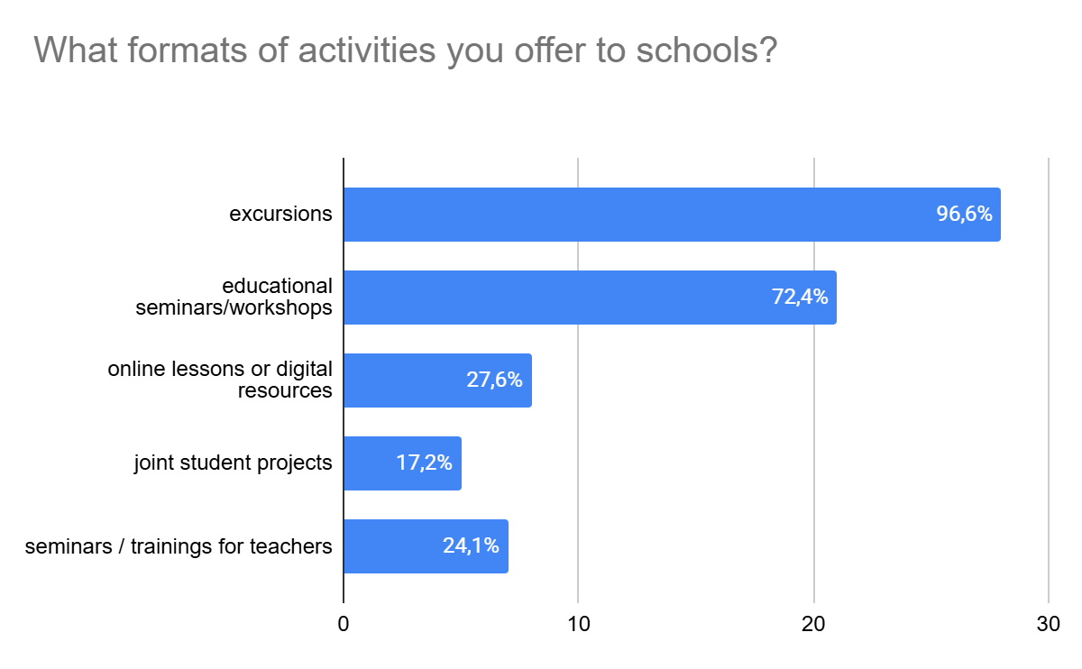
What formats of activities does your museum offer to schools?

Respondents repeatedly emphasise that it is difficult for children to be passive listeners, and museum staff introduces interactive elements in their activities, where the student moves from the role of a listener to the role of a participant or co-creator. The Rivne Regional Museum of Local Lore has implemented the "Museum Guide School" project for several years in a row, within the framework of which students in grades 9-10 had the opportunity to contribute to creation of museum exhibitions. At the Korsaks Museum, pedagogy is based on interactivity, experiments, STEM, art, performativity, and the desire to transform the visitor's experience. However, this practice is still fragmented and often depends on the initiative of individual employees, rather than on a systematic methodological effort. Museum educators ask for more training in facilitating school visits and educational design, in order to better transform a museum resource into an experiential learning with school groups.
The data from the online survey shows that in most cases, the museum supports the school curriculum: it provides a subject-related, local or emotional context to the topics studied in the classroom. At the Municipal Institution "Vinnytsia Museum", educational programmes circle around state symbols, the events of the Ukrainian Revolution, while the material is aimed at students in grades 10-11. In the Khortytsia National Reserve, museum routes and marathons are linked to the history of Ukraine and the local history of the Ukrainian Cossacks taught at school. At the National Museum of the History of Ukraine in the Second World War, classes on propaganda and disinformation work as a tool for media literacy and civic education.
At the same time, the interviews show that linking museum activities to the curriculum is often the responsibility of a sole teacher. Where the teacher builds the museum visit around the topics taught at school, the museum resource becomes part of the learning; otherwise, it remains a stand-alone experience, disconnected from the broader curriculum. Some museums, like the National Museum of History of Ukraine, aim to support the teachers and develop dedicated educational resources closely linked to school curriculum. The O.K. Antonov State Museum of Aviation of Ukraine of the State University "Kyiv Aviation Institute" links its collection with science and STEM subjects.
Several respondents mention that systemic integration of the museum activities into school curriculum requires new mechanisms for cooperation between teachers, municipal departments of education, and museum educators.
Finally, the study also showed a communication gap between schools and museums. Many schools are not aware of the existing museum programmes, online resources, or their ability to adapt museum activities to a specific topic. Museums, in turn, do not always understand what specific educational needs a school has and what time, security, and administrative constraints it operates with. School-museum cooperation would benefit from closer contact via dedicated coordinators and regular communication.

Complex topics, shared trauma and safe educational space

A number of respondents report that after the beginning of the full-scale war, complex, traumatic topics became the key issue of current museum education in Ukraine. 62.1% of the museums that took part in the online survey confirmed that they work with complex and sensitive topics, and 31% work with them partially.
Almost all the institutions studied directly or indirectly work with the topics of war, loss, occupation, violence, memory, forced displacement, repression, the Holocaust, the Holodomor and current challenges in the Ukrainian society. As also reported by teachers in the separate survey, the war has changed even the approaches to presenting established historical narratives that were previously considered "distanced" from modern experience. Ukrainian museums are increasingly functioning not only as a space for the transfer of knowledge, but also as an environment for working with collective and personal trauma.
The interviews show that museums are aware of the need to adapt complex topics to the age but they do not always possess the expertise to do so. Director of the Zdolbuniv Museum of Local Lore named after Oleh Tyshchenko explained: "We deliberately avoid younger schoolchildren... Again, the specifics of the museum (the museum is located in the premises of a former prison and its exhibition is mostly related to the topic of repression – T. Samsoniuk). We haven't learned how to do this."
At the same time, the analysis of the interviews shows that even under conditions of adaptation, museums regularly encounter strong emotional reactions from children and adults. This is especially true for regions where there is a large number of internally displaced persons, families of fallen soldiers or children with experience of occupation. Respondents mentioned cases of crying, children leaving the hall, and emotional reactions from teachers. One of the most powerful fragments of an interview concerned a girl who saw a portrait of her deceased father during a tour: “She came up and just started stroking it and crying.” Museums often work not with abstract history, but with directly experienced trauma.
Separately, the interviews show that the museum staff themselves are also part of a shared traumatic environment. They work with topics that are often directly related to their own experiences of war, loss or emotional exhaustion. Museum representatives state directly: “We ourselves are very often traumatised.” Such shared traumatic experience (shared trauma education), where both the museum worker and the audience are experiencing trauma, requires a safe space to work in, which includes not only physical safety (the availability of shelters, procedures during air raid alerts), but also psychological safety: careful language, age adaptation, support for emotional reactions and the avoidance of excessive details.
The study also showed that museums are often forced to act intuitively, without sufficient methodological and psychological training. Despite some examples of training and internal education, most respondents emphasised the need for additional professional development in working with complex topics, including not only psycho-social support, but also inclusion of all, facilitation of dialogue and trauma-informed cooperation with schools.

Impact of museum-school cooperation

Museums consider cooperation with schools as a much broader process than just the transfer of knowledge. Respondents increasingly understand their impact as a long-term socio-cultural process. It is not just about whether a child "remembered something" after a tour, but about the formation of a museum habit, cultural participation, local and national identity, civic resilience, interest in research, or even a future career path. This is especially noticeable in cases where students return to the museum again, involve their parents, participate in research projects, volunteer, or later join the museum sector as employees. In wartime Ukraine, museums that work with the themes of loss, memory and modern war become spaces for collective experience and social understanding of traumatic experiences.
At the same time, there is a significant problem with the measurability of the impact. Despite numerous examples of successful cases, museums mainly evaluate the results of their work through indirect indicators such as: emotional reactions of children and teachers, repeat visits, verbal feedback. While in most cases, museums do not track what knowledge or competencies have been shaped, how students' values and attitudes have changed, or whether the effect is sustained in the long term.
This creates a situation where a significant part of the cultural and educational value of the school-museum cooperation remains “invisible” to educational policy and strategic planning. Without the use of relevant evaluation tools, it is more difficult for museums to substantiate the social value of their work, receive funding, scale up successful practices, integrate into educational policy, and prove the effectiveness of long-term programmes. Further development in this area requires a transition from a predominantly intuitive and descriptive understanding of results to a more systematic approach to assessing the effectiveness of museum education in Ukraine.

Summary and Recommendations

Cooperation of schools and museums is a powerful driver of civic education, transforming abstract concepts like democracy, human rights, and collective memory into tangible, lived experiences. The study shows that both cultural and educational sectors in Ukraine have strong interest in close interaction and see high pedagogic value and impact in shared work with school children.
The school-museum cooperation in the country is shaped by significant differences in security, geography, institutional capacity, and access to cultural infrastructure. The war has intensified these inequalities. While schools in relatively stable urban areas can use museums as resources for civic education, research, local history, and curriculum enrichment, schools in frontline, border, and de-occupied areas often face restrictions caused by security risks, online learning, limited mobility, and the need to prioritise psychological stabilisation and the restoration of education.
The study indicates that the future of the school-museum cooperation in Ukraine largely depends on its institutionalisation. Museums and schools want their cooperation to move beyond ad hoc contacts between individual teachers and museum professionals and become part of a stable educational policy. Education departments, local governments, and cultural authorities can play an important role as coordinators and intermediaries. The findings suggest that where managerial support exists, museum programmes are more regular, reach more schools, and are more sustainable.
At the same time, institutionalisation requires investment in people and expertise. There is a large need for museum educators, educational designers, facilitators, and school-cooperation coordinators. This points to the growing professionalisation of museum pedagogy as a distinct area of expertise. The war has fundamentally changed the context in which museums and schools address difficult and sometimes controversial topics. Current war experiences, including loss, displacement, occupation, danger, and uncertainty require approaches based on trauma-informed pedagogy, flexible facilitation, sensitivity to individual experiences. This calls for a more trauma-informed approach to museum education, in which museums provide not only educational opportunities but also spaces for safe interaction, reflection, and dialogue. Museum educators note the need for a stronger professional development to address complex and sensitive issues with school groups. Greater communication and preparation between teachers and museum educators is also essential to ensure that difficult topics are addressed in ways that are both educationally meaningful and psychologically safe.
Another priority is integration of museum activities in the learning process. While the majority of the museum visits are fully or partially linked to the curriculum, this often is the responsibility of a single teacher who establishes learning goals, prepares students beforehand, provides research or reflective tasks, and follows up the museum experience in class. The shift towards a broader ecosystem of partnerships is needed, when museums and schools are supported by the local educational authorities, and other local actors in a single systemic educational process supported by funding schemes, compensation mechanisms, and subsidy programmes. Curriculum-tailored educational resources developed by the museum teams are also contributing largely to good pedagogic results.
Diversification of educational formats in the museum space remains a challenge. The most promising models combine on-site museum visits with outreach programmes, online classes, digital resources, teacher materials, and interactive and interdisciplinary activities. In wartime, mobile and online formats are particularly important for reaching frontline, remote, and displaced communities. Digitalisation is an essential condition for the accessibility and continuity of museum education, whereas digital provision should complement rather than replace opportunities for physical interaction with museum collections and spaces whenever conditions allow.
Finally, there is a need for a more evidence-based approach to museum education. Although museums report significant educational and social impact, they often lack systematic ways to demonstrate it. Simple evaluation mechanisms, such as participant feedback, monitoring repeat visits, documenting student learning trajectories, collecting qualitative impact stories, and tracking longer-term outcomes, could help museums demonstrate their value to the state, communities, and donors.
Overall, there is a growing shift towards redefining the museum as an active educational, civic, and social partner. Effective school-museum cooperation depends on institutional support, equitable access, professional capacity, meaningful curriculum integration, active learning formats, and the ability to adapt museum education to the realities of wartime Ukraine.

Based on the key findings of the research, a set of recommendations for different stakeholders has been developed to strengthen cooperation between schools and museums.

For the national government, ministries of education and culture, as well as local governments (hromadas):
- Introduce state- or municipally funded programs to ensure access of school children to cultural experience, including covering transport logistics and museum fees for schools.
- Invest in converting basement spaces of museums into multimedia-equipped shelters for uninterrupted learning during air raids.
For higher educational institutions, in-service teacher training institutes and NGOs:
- Embed more training courses in the field of Museum Pedagogy and Educational Design into university programs for teacher education and museum experts, include similar educational programs in the regional in-service teacher training institutes.
- Develop more opportunities for professional development of museum educators within educational, cultural and social projects carried out by civil society organizations.
For museums:
- Conduct trauma-informed audits of war-related exhibits and adjust to the work with the school audience. Introduce pre-visit coordination between teachers and museum educators, including assessing class composition and psycho-emotional readiness. Organise systematic training on psychological first aid and crisis communication for museum educators.
- Reallocate internal staff positions to establish or reinforce teams of museum educators focused on curriculum-aligned interactive programming, invest in their professional development.
- Use interactive participatory approaches when working with school children.
- Provide digital educational resources for schools on museums’ websites, actively promote them.
- When developing educational programmes, emphasise topics that are scarce in schools, e.g. media literacy, digital security, complex, controversial and traumatic events in history, closely linking educational packages to curriculum.
For schools:
- Aim for long-term collaboration, transitioning from single events to formal cooperation that lock regular off-site learning into the annual academic timetable, e.g. planning for regular "days outside the classroom".
- Invite civil society organizations as mediators in cooperation with museums.
- Choose a dedicated teacher coordinator cooperating with the museums.
- When working with a museum, plan for a good preparation and a post-visit reflection.

Best Practice Example: VMUZEI (ne)dribnytsi na urotsi" (Dnipro)

One of the brightest examples of the systematic integration of museums’ programmes into the educational process is the initiative "VMUZEI: (ne)dribnytsi na urotsi" (InMUSEUMS: (non)trivial lessons), implemented in the city of Dnipro. The project turned museum excursions into regular learning in a cultural space closely linked to school curriculum.

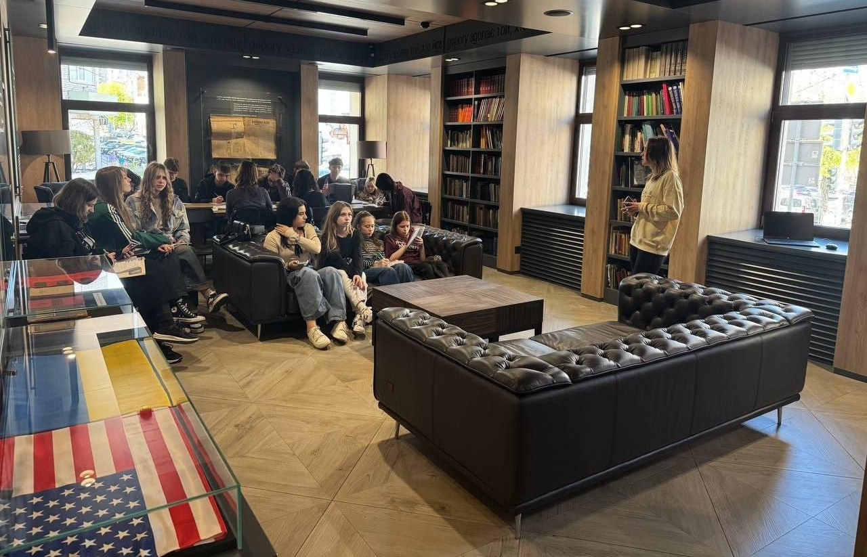
Photo: official page of the project "VMUZEI. (ne)dribnytsi na urotsi" https://www.facebook.com/p/%D0%92-%D0%9C%D0%A3%D0%97%D0%95%D0%87-61550114934885/
‌
The initiative was launched by local teachers and supported by the Department of Humanitarian Policy of the city of Dnipro and brought together schools with various cultural institutions in the city. As of 2026, the Dnipro History Museum, the Dnipro Art Museum, the John McCain Library, the Vadym Sidur Museum Room, the Planetarium Noosphere, and other spaces, and 35 schools have joined the project.
Within the framework of the project, museums and other cultural institutions carry out lessons in Ukrainian language and literature, history, geography, physics, biology, art, astronomy, as well as interdisciplinary integrated classes in cooperation with the schools, whereas the museum is not an “add-on” to a lesson, but a full-fledged educational partner.
During the lessons, the teacher does not hand over the initiative to the museum worker completely, but utilises the museum as a learning environment, and uses its resources to immerse the students into the topic. In the Dnipro Art Museum, for example, lessons in Ukrainian literature or art are held directly among the exhibits, and the paintings are used as pedagogical tools, becoming the part of the analysis and interpretation of the educational material. Another example are STEM classes at Planetarium Noosphere, where schoolchildren study the topics of space, ecology and science through interactive space programmes, visualisation and direct immersion in the planetarium space.
"VMUZEI: (ne)dribnytsi na urotsi" is one of the successful examples of cooperation between schools and museums in Ukraine which demonstrated effective and systemic urban integration receiving positive feedback both from students, teachers and museum workers.

Annex 1. Results of the Online Survey for Schools

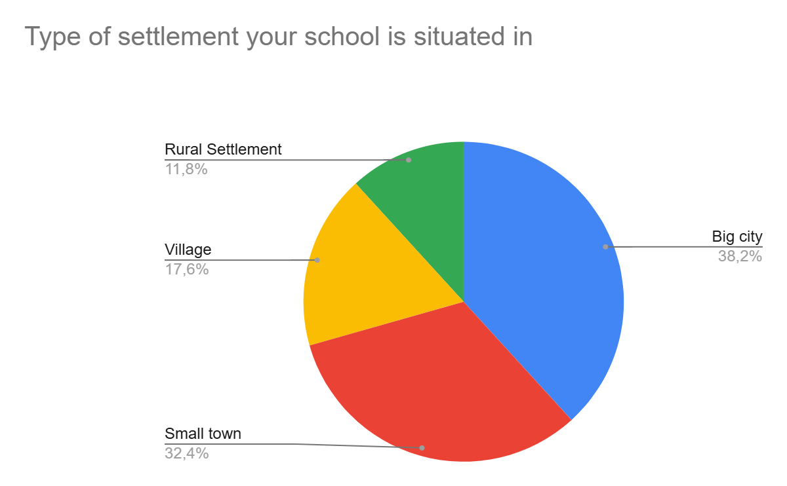
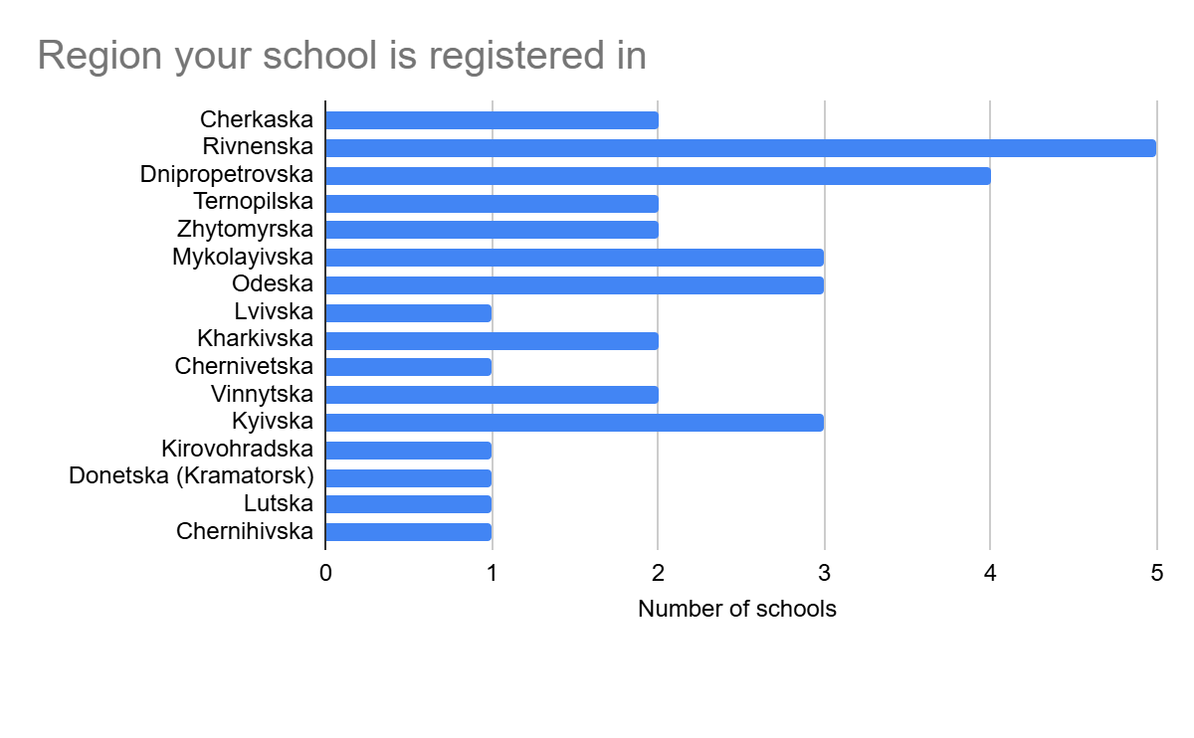
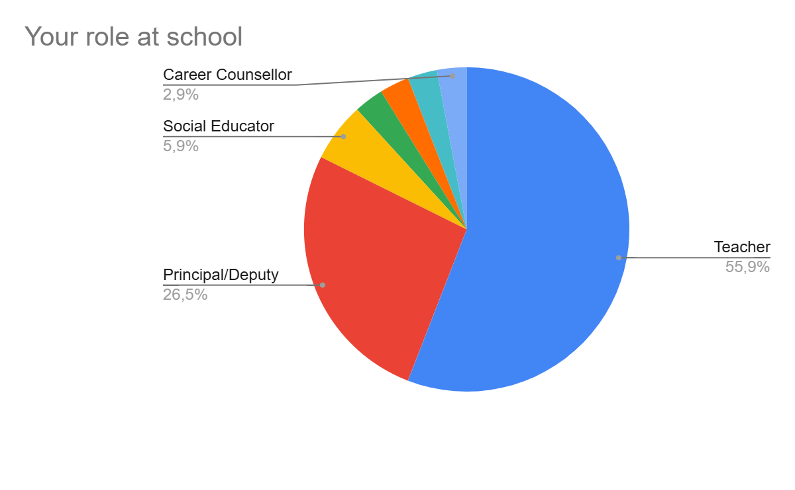
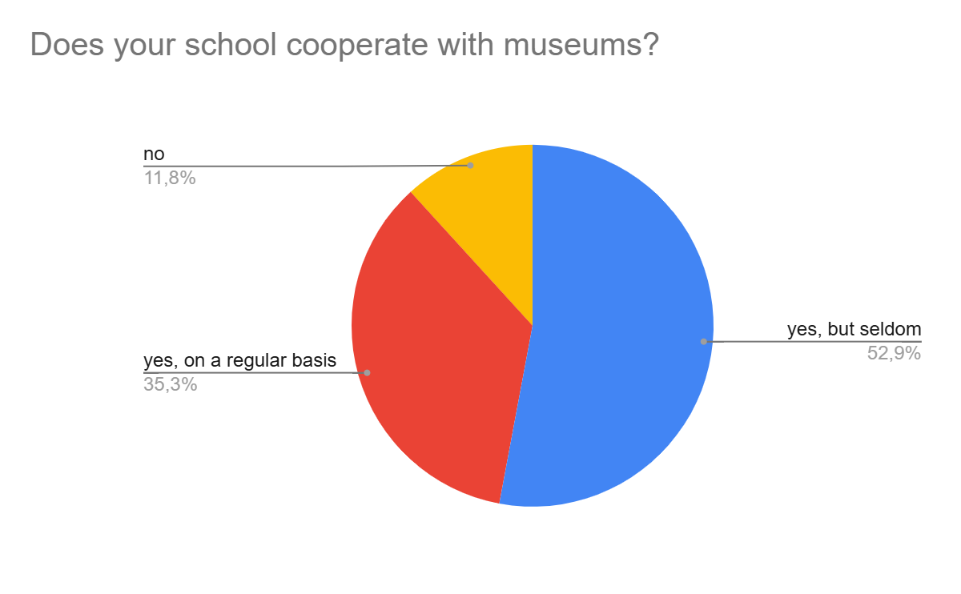

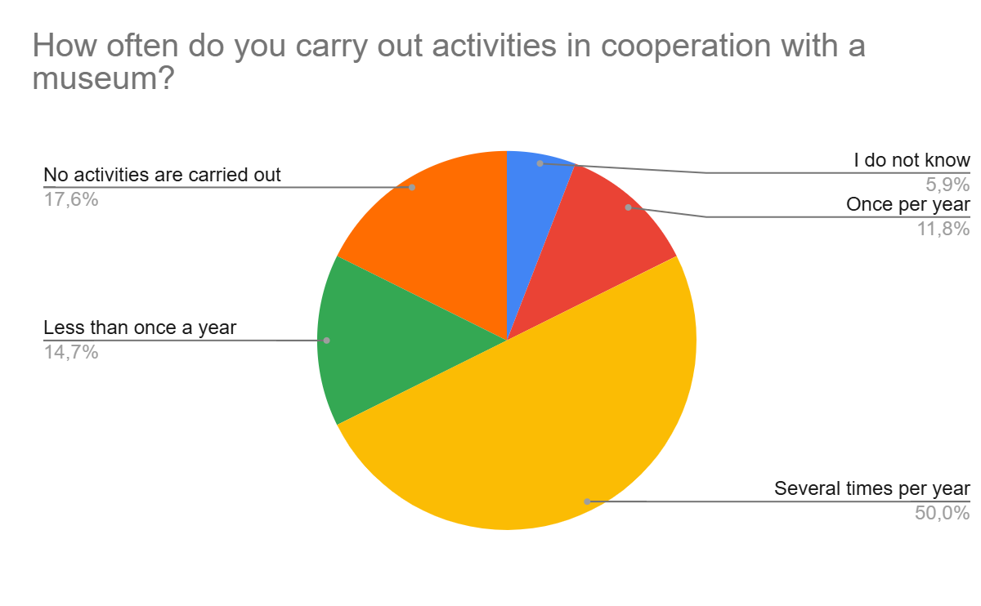

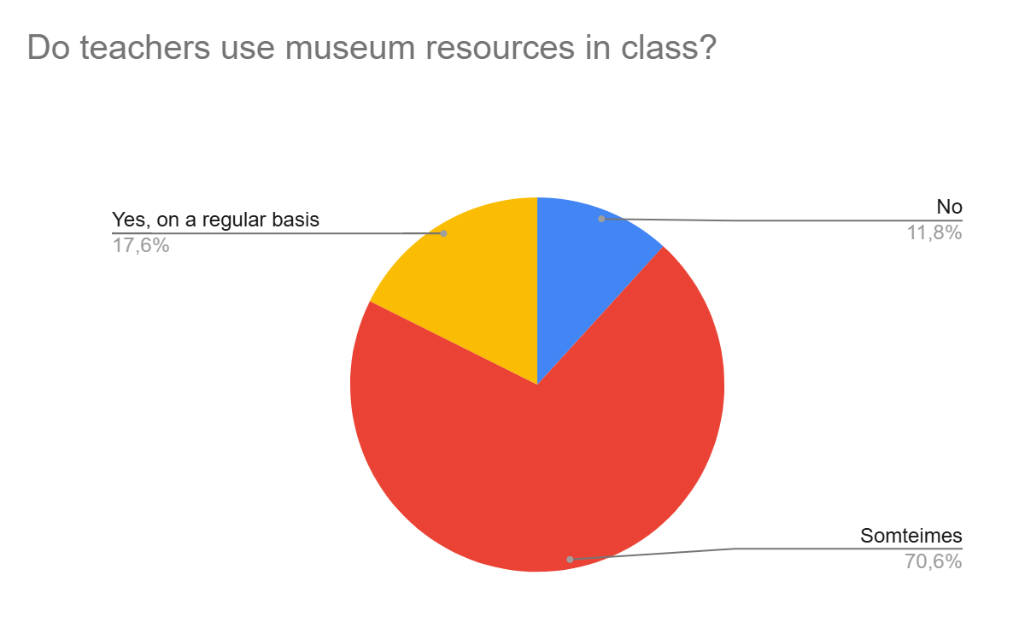
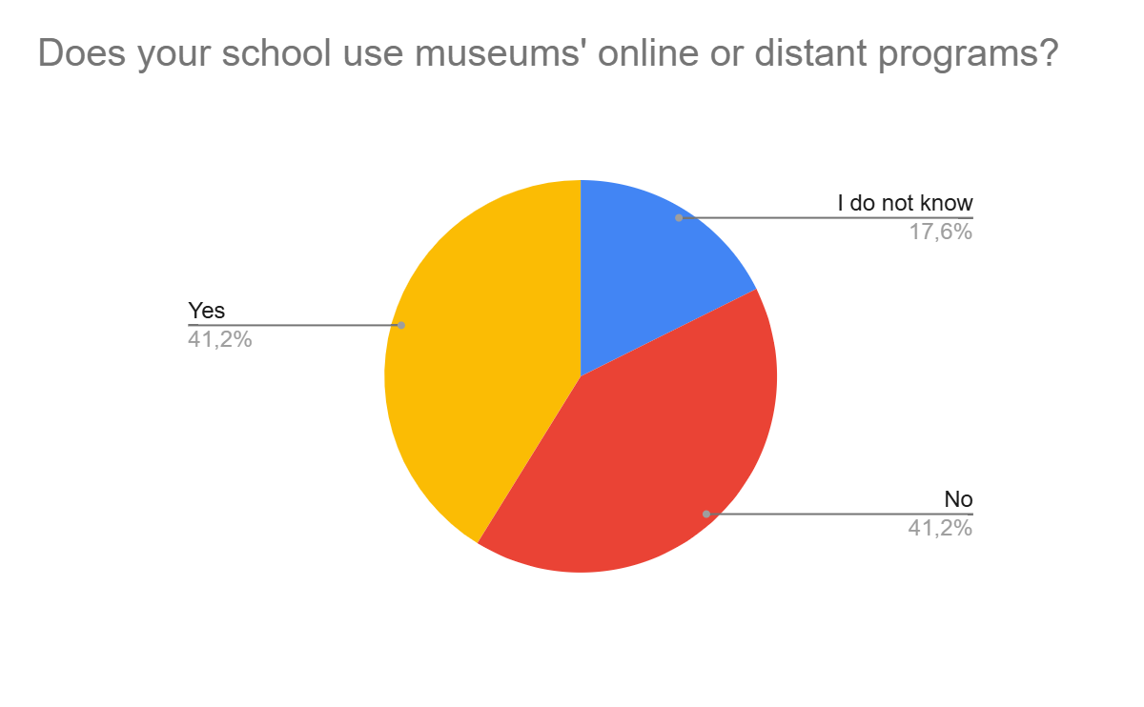

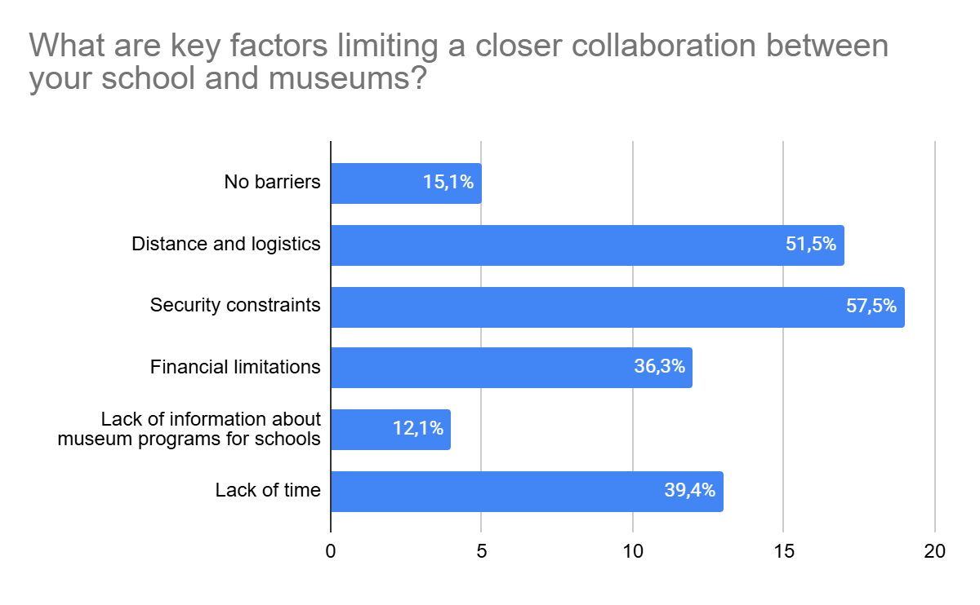
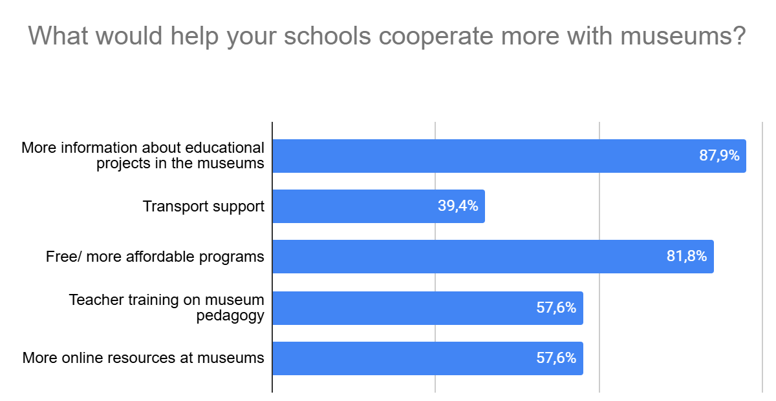
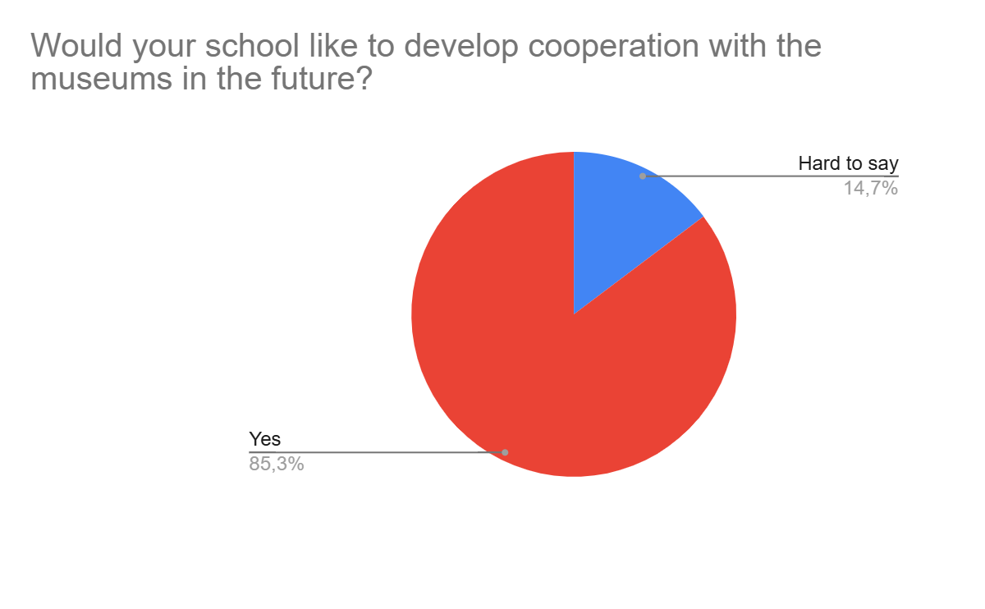

Annex 2. Results of the Online Survey for Museums
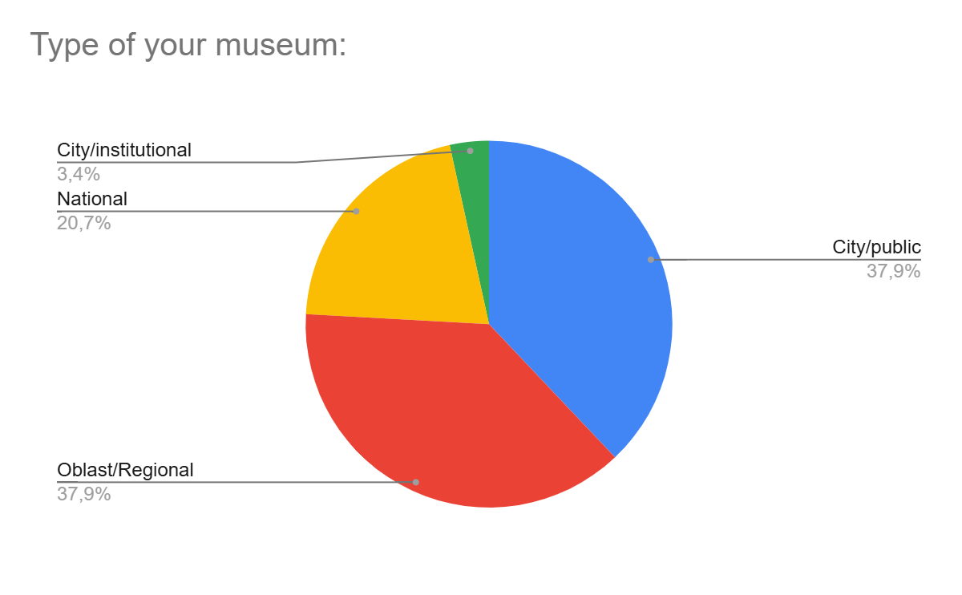
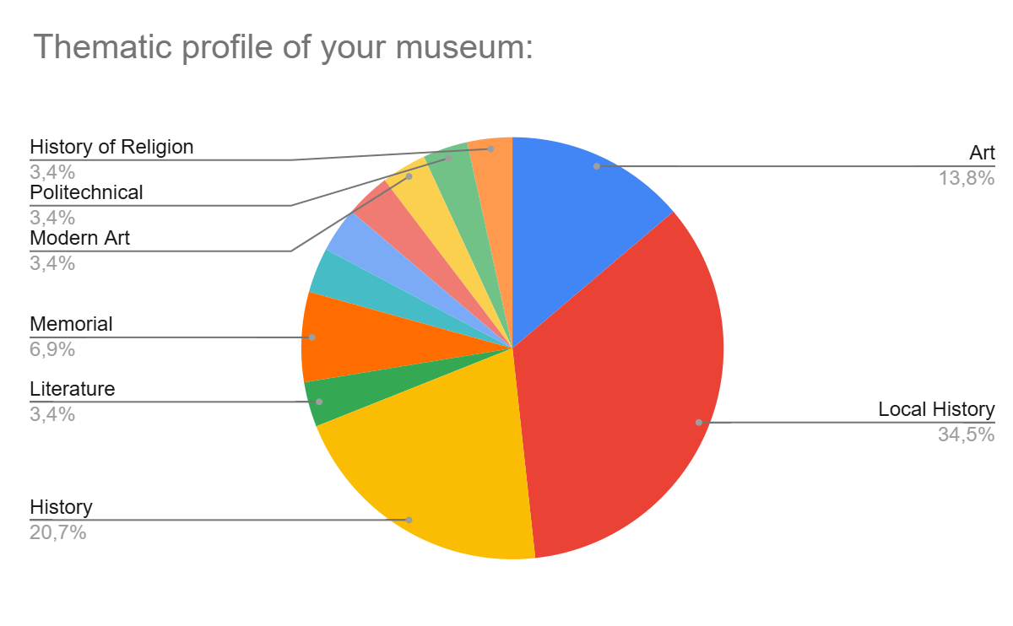
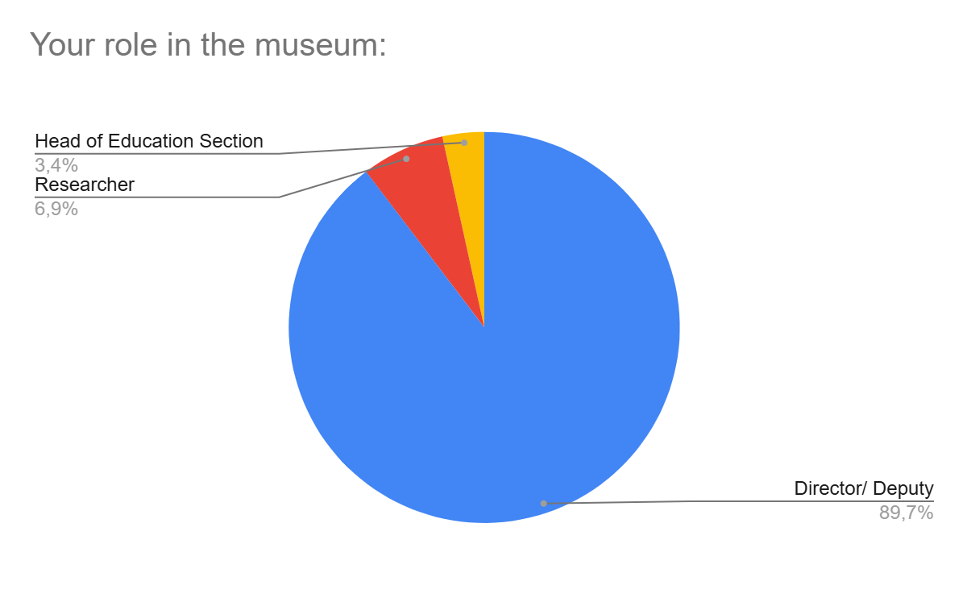
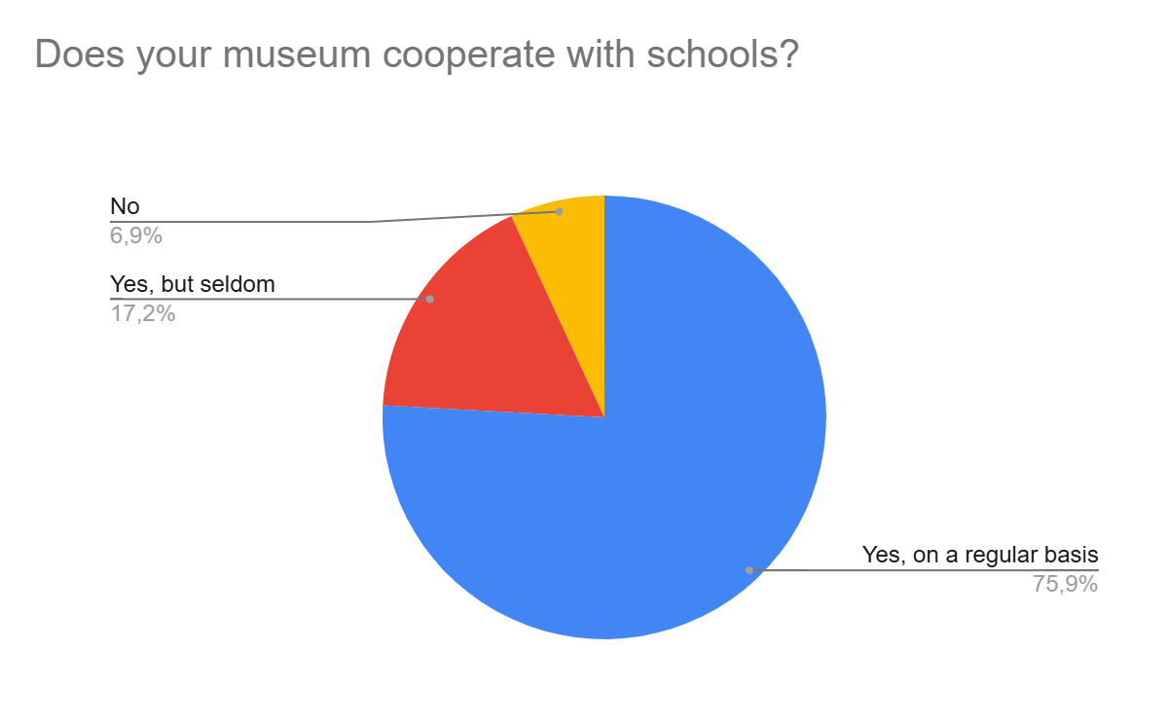
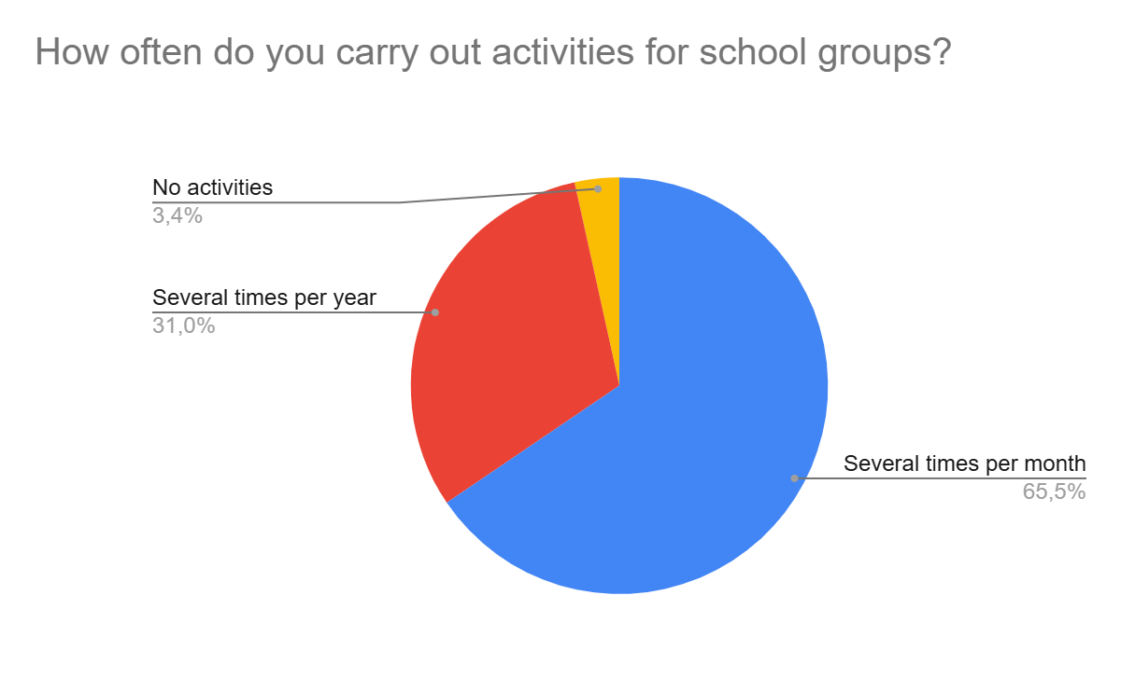
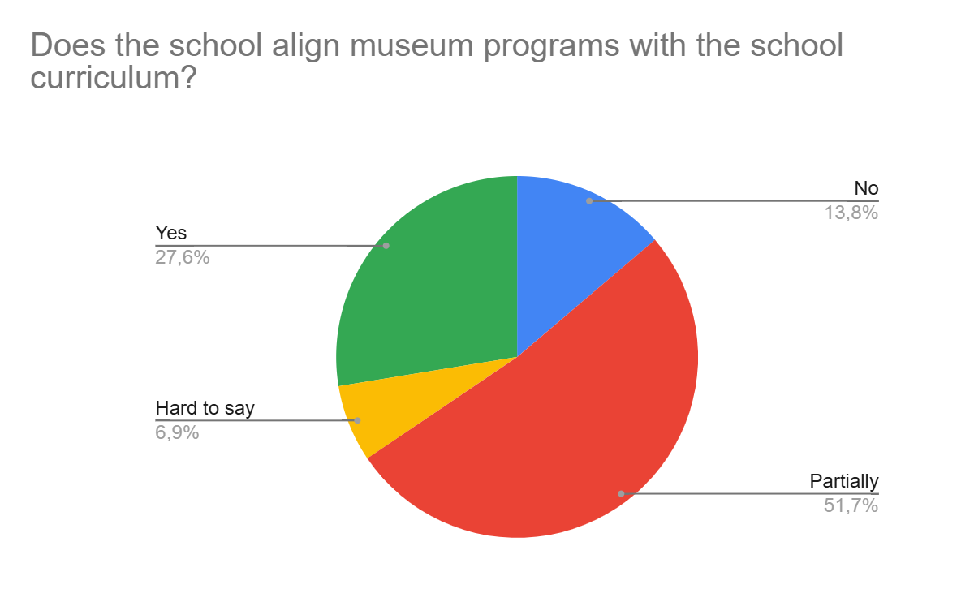
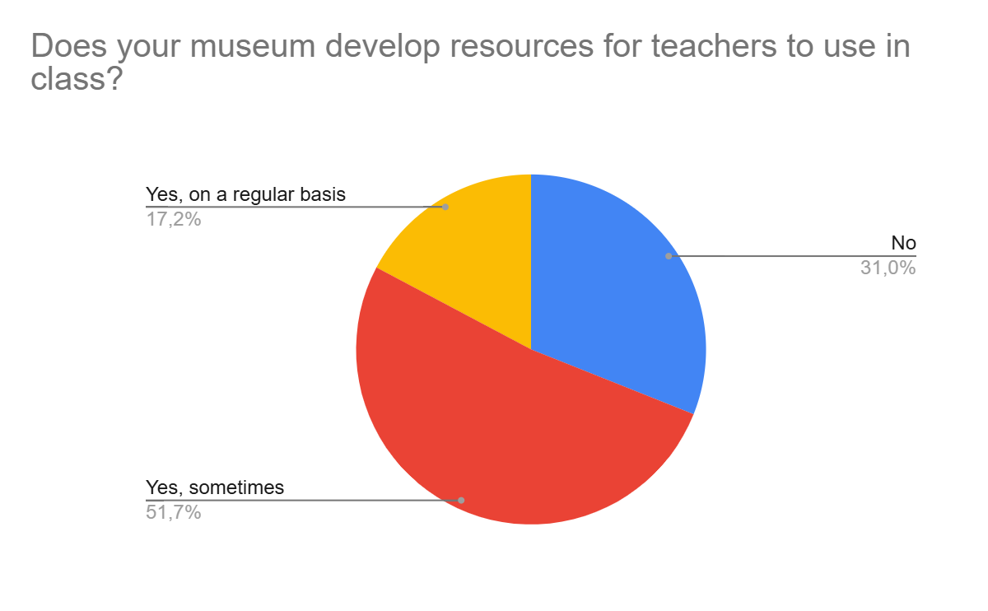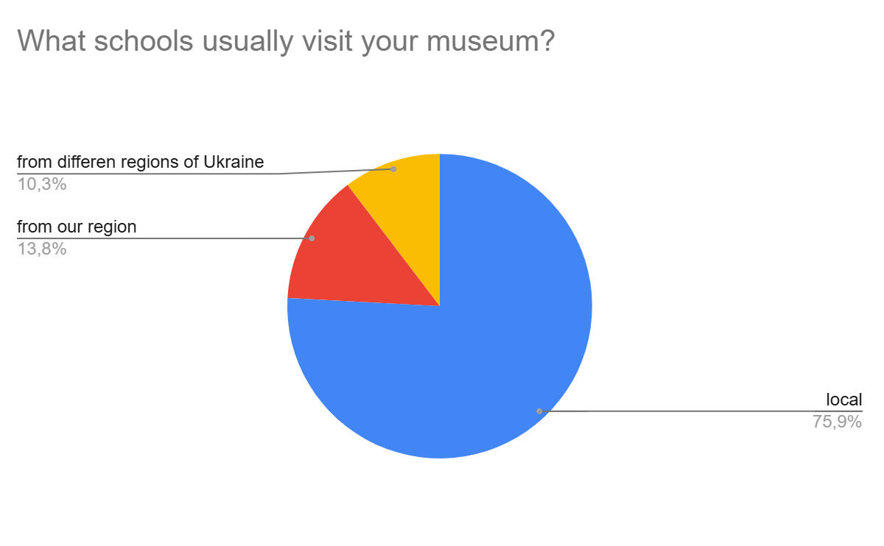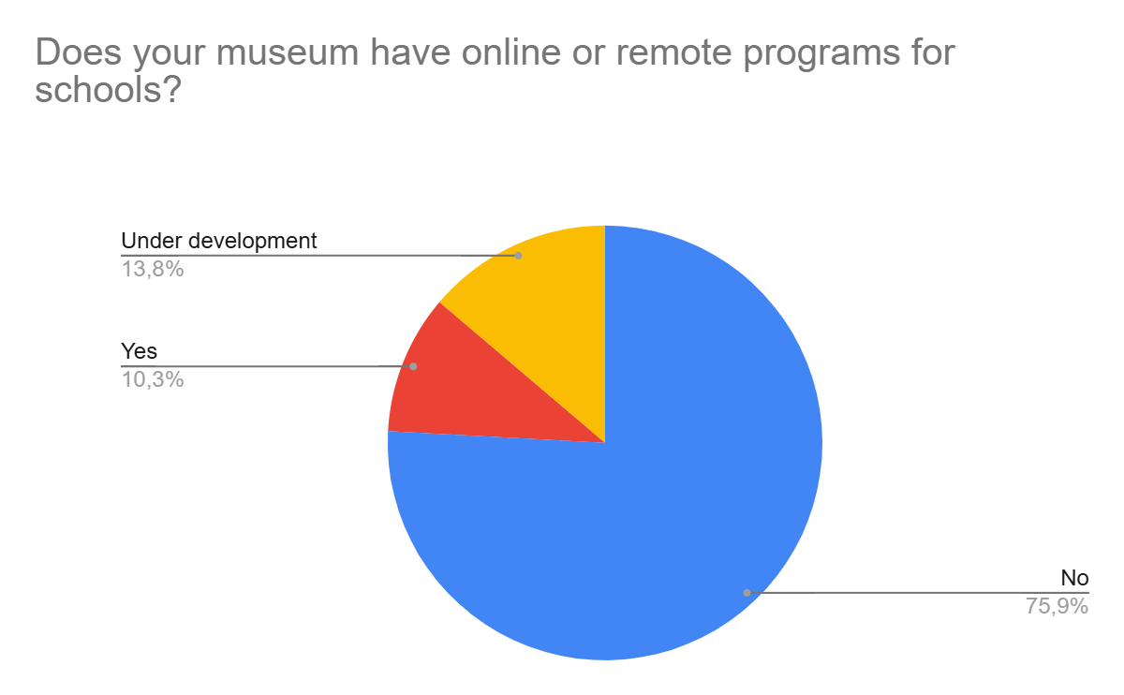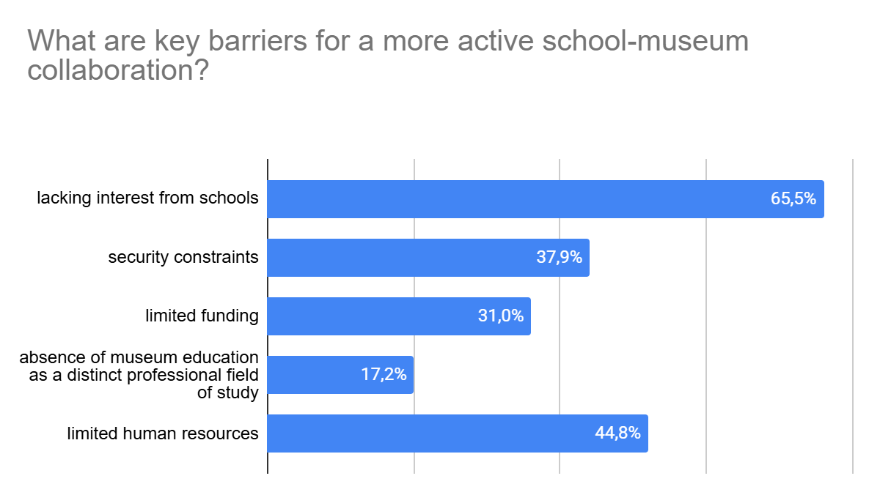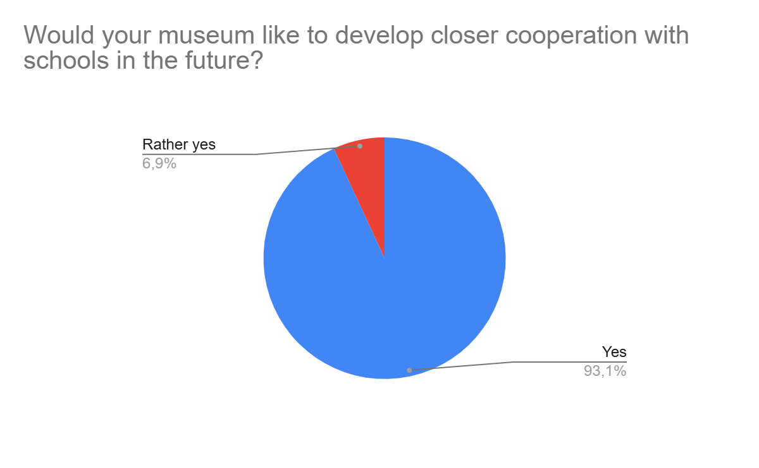

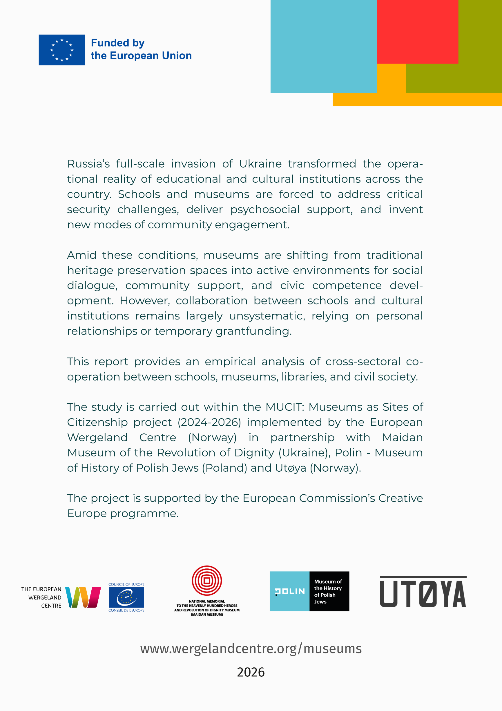

Mankovska, R. 2019. “Museum pedagogy: innovative technology for intellectual development.” Kraieznavstvo, no. 3: 238–51. https://kraieznavstvo.history.org.ua/cgi-bin/krzn/jrn.exe?I21DBN=LINK&P21DBN=krzn&Z21ID=&S21REF=10&S21CNR=20&S21STN=1&S21FMT=ASP_meta&C21COM=S&2_S21P03=FILA=&2_S21STR=kraeznavstvo_2019_3_23.
Chervinska, Inna. 2019. “Museum pedagogy as a tool for interaction between educational institutions and museums in the modern socio-cultural space.” Educational Horizons 49 (2): 16–21. https://doi.org/10.15330/obrii.49.2.16-21.
Museum pedagogy under martial law. Collection of materials of the International Round Table. n.d. Accessed June 17, 2026. https://undip.org.ua/wp-content/uploads/2022/10/Zbirnyk_2022_w.pdf.
.Ovcharuk O. V. Theory and practice of school education for democratic citizenship in the member states of the Council of Europe [Text]: monograph / Oksana Ovcharuk; National Academy of Educational Sciences of Ukraine, Institute of Information Technologies and Teaching Aids. - Kyiv: Phoenix, 2021. - 399 p.
“Museums and Schools Working Together.” n.d. https://gem.org.uk/wp-content/uploads/2018/01/GEM-Case-Studies-vol.16-Special-Edition-Museums-and-Schools.pdf.
“Museums Galleries Scotland | Working with Schools.” 2025. Museums Galleries Scotland. 4 November 2025. https://www.museumsgalleriesscotland.org.uk/advice-article/working-with-schools/.
Gómez-Hurtado, Inmaculada, José María Cuenca-López, and Beatrice Borghi. 2020. “Good Educational Practices for the Development of Inclusive Heritage Education at School through the Museum: A Multi-Case Study in Bologna.” Sustainability 12 (20): 8736. https://doi.org/10.3390/su12208736.
Riveiro-Rodríguez, Tania, Andrés Domínguez-Almansa, Ramón López Facal, and Tomás Izquierdo Rus. 2021. “Place-Based Education and Heritage Education in In-Service Teacher Training: Research on Teaching Practices in Secondary Schools in Galicia (NW Spain).” Humanities and Social Sciences Communications 8 (1). https://doi.org/10.1057/s41599-020-00689-3.
2026. Cimam.Org. 2026. https://cimam.org/resources-publications/unesco-recommendation-concerning-the-protection-and-promotion-of-museums-and-collections/?utm_source=chatgpt.com.
Gigerl, Monika, Josep M Sanahuja-Gavaldà, Rozita Petrinska-Labudovikj, Mar Moron-Velasco, Susana Rojas-Pernia, and Ulrich Tragatschnig. 2022. “Collaboration between Schools and Museums for Inclusive Cultural Education: Findings from the INARTdis-Project.” Frontiers in Education 7 (October): 979260. https://doi.org/10.3389/feduc.2022.979260.
“Digital Learning and Education in Museums Innovative Approaches and Insights a NEMO Report by LEM the Learning Museum Working Group.” n.d. https://www.ne-mo.org/fileadmin/Dateien/public/Publications/NEMO_Working_Group_LEM_Report_Digital_Learning_and_Education_in_Museums_12.2022.pdf.
Living with Controversy - Teaching Controversial Issues Through Education for Democratic Citizenship and Human Rights (EDC/HRE) - Training Pack for Teachers. - Council of Europe, 2015. https://edoc.coe.int/en/human-rights-democratic-citizenship-and-interculturalism/7738-teaching-controversial-issues.html
Measuring visitors' learning in museums, libraries and archives “REF Case Study Search”. 2021. Ref.Ac.Uk. 2021. https://impact.ref.ac.uk/casestudies/CaseStudy.aspx?Id=30365.
“On Education.” 2017. Official web portal of the Parliament of Ukraine. 2017. https://zakon.rada.gov.ua/laws/show/2145-19/ed20240104#Text.
“On Complete General Secondary Education.” 2020. Official web portal of the Parliament of Ukraine. 2020. https://zakon.rada.gov.ua/laws/show/463-20#Text.
“On Amendments to Certain Laws of Ukraine on Improving the Mechanisms for Forming a Network of Lyceums for the Introduction of High-Quality Specialised Secondary Education.” 2021. Official web portal of the Parliament of Ukraine. 2021. https://zakon.rada.gov.ua/laws/main/1658-20?utm_source=chatgpt.com#Text.
“On the approval of the State Standard for specialised secondary education.” 2024. Official web portal of the Parliament of Ukraine. 2024. https://zakon.rada.gov.ua/laws/show/851-2024-%D0%BF#Text.
“On Museums and Museum Affairs.” 2025. Official web portal of the Parliament of Ukraine. 2025. https://zakon.rada.gov.ua/laws/main/249/95-%D0%B2%D1%80?utm_source=chatgpt.com#Text.
“On Extracurricular Education.” 2026. Official web portal of the Parliament of Ukraine. 2026. https://zakon.rada.gov.ua/laws/show/1841-14#Text.

